
CALENDAR and CARDS
ORDER FORM 2021

Please consider helping with this fundraising event for (FoStA) the Friends of St. Andrew’s this Christmas

It would be helpful if all orders could reach me by 5th December at the latest.

If mail order is required for more than one item please add £3.20 to cover p&p. Thank You.

For those wishing to order by e-mail please use my personal address: ianandvalstratton@hotmail.co.uk

Cheques should be made payable to FoStA and included with your order or payment can be direct to the FoStA bank account at: TSB Bude Sort Code: 30-91-41 Account No. 00586386. Please mark your payment Calendar

NAME…………………………………………………………………………………………………………………

ADDRESS………………………………………………………………………..........................................................

………………………………………………………………………………………………………………………….

TELEPHONE No……………………………………………………………………………………………………..

- Please complete your name, address and telephone number above
- Indicate your requirements on the order form below
- Please post your orders to: Mrs Val Barker, Chynoweth, Bowden, Stratton, Bude. EX23 9BH

Number of calendars @ £4 each | Package and Postage | SubTotal
Please indicate the number of packs required for each card type. Each pack will contain 5 cards with envelopes.

A Stratton Carol  £5 per pack | The Crib  £4 per pack | Tryptic  £4 per pack | Holy Family  £4 per pack | BVM vintage  £4 per pack | BVM colour  £4 per pack | Donation | SubTotal
 |  |  |  |  |  | GRAND TOTAL | £


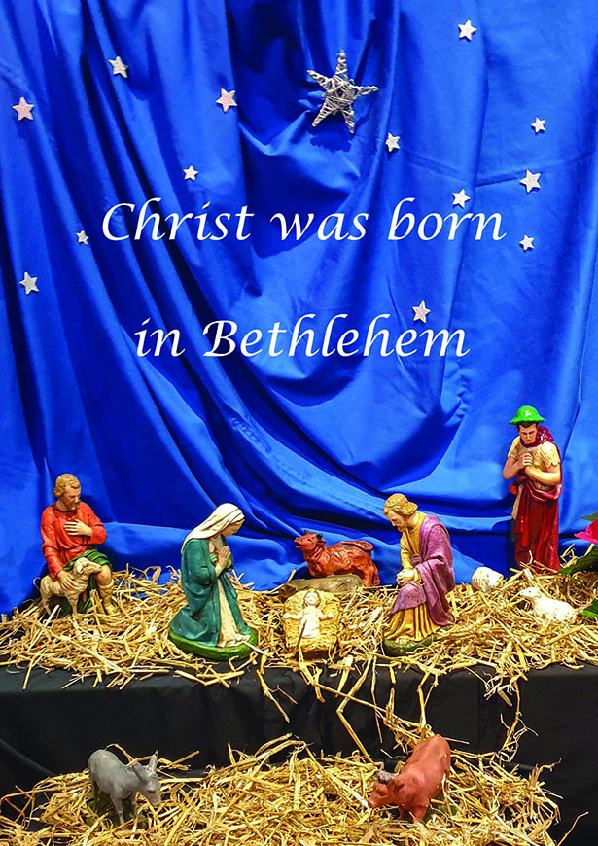

The Crib Tryptic

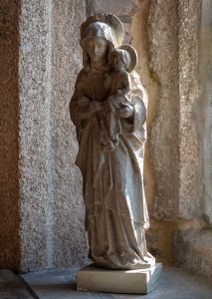


BVM colour

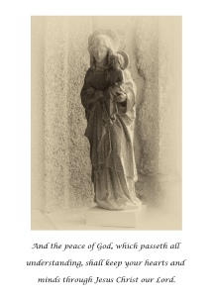

BVM vintage
A Stratton Carol
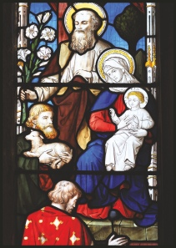

Please be aware that these pictures are
for illustration purposes only.
A Stratton Carol (DL) measures 99mm x 210mm
with all the others being A6 and measuring
105mm x 148mm approximately.

Holy Family

