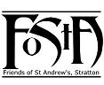
Friends of St Andrew’s Church
Stratton, Cornwall
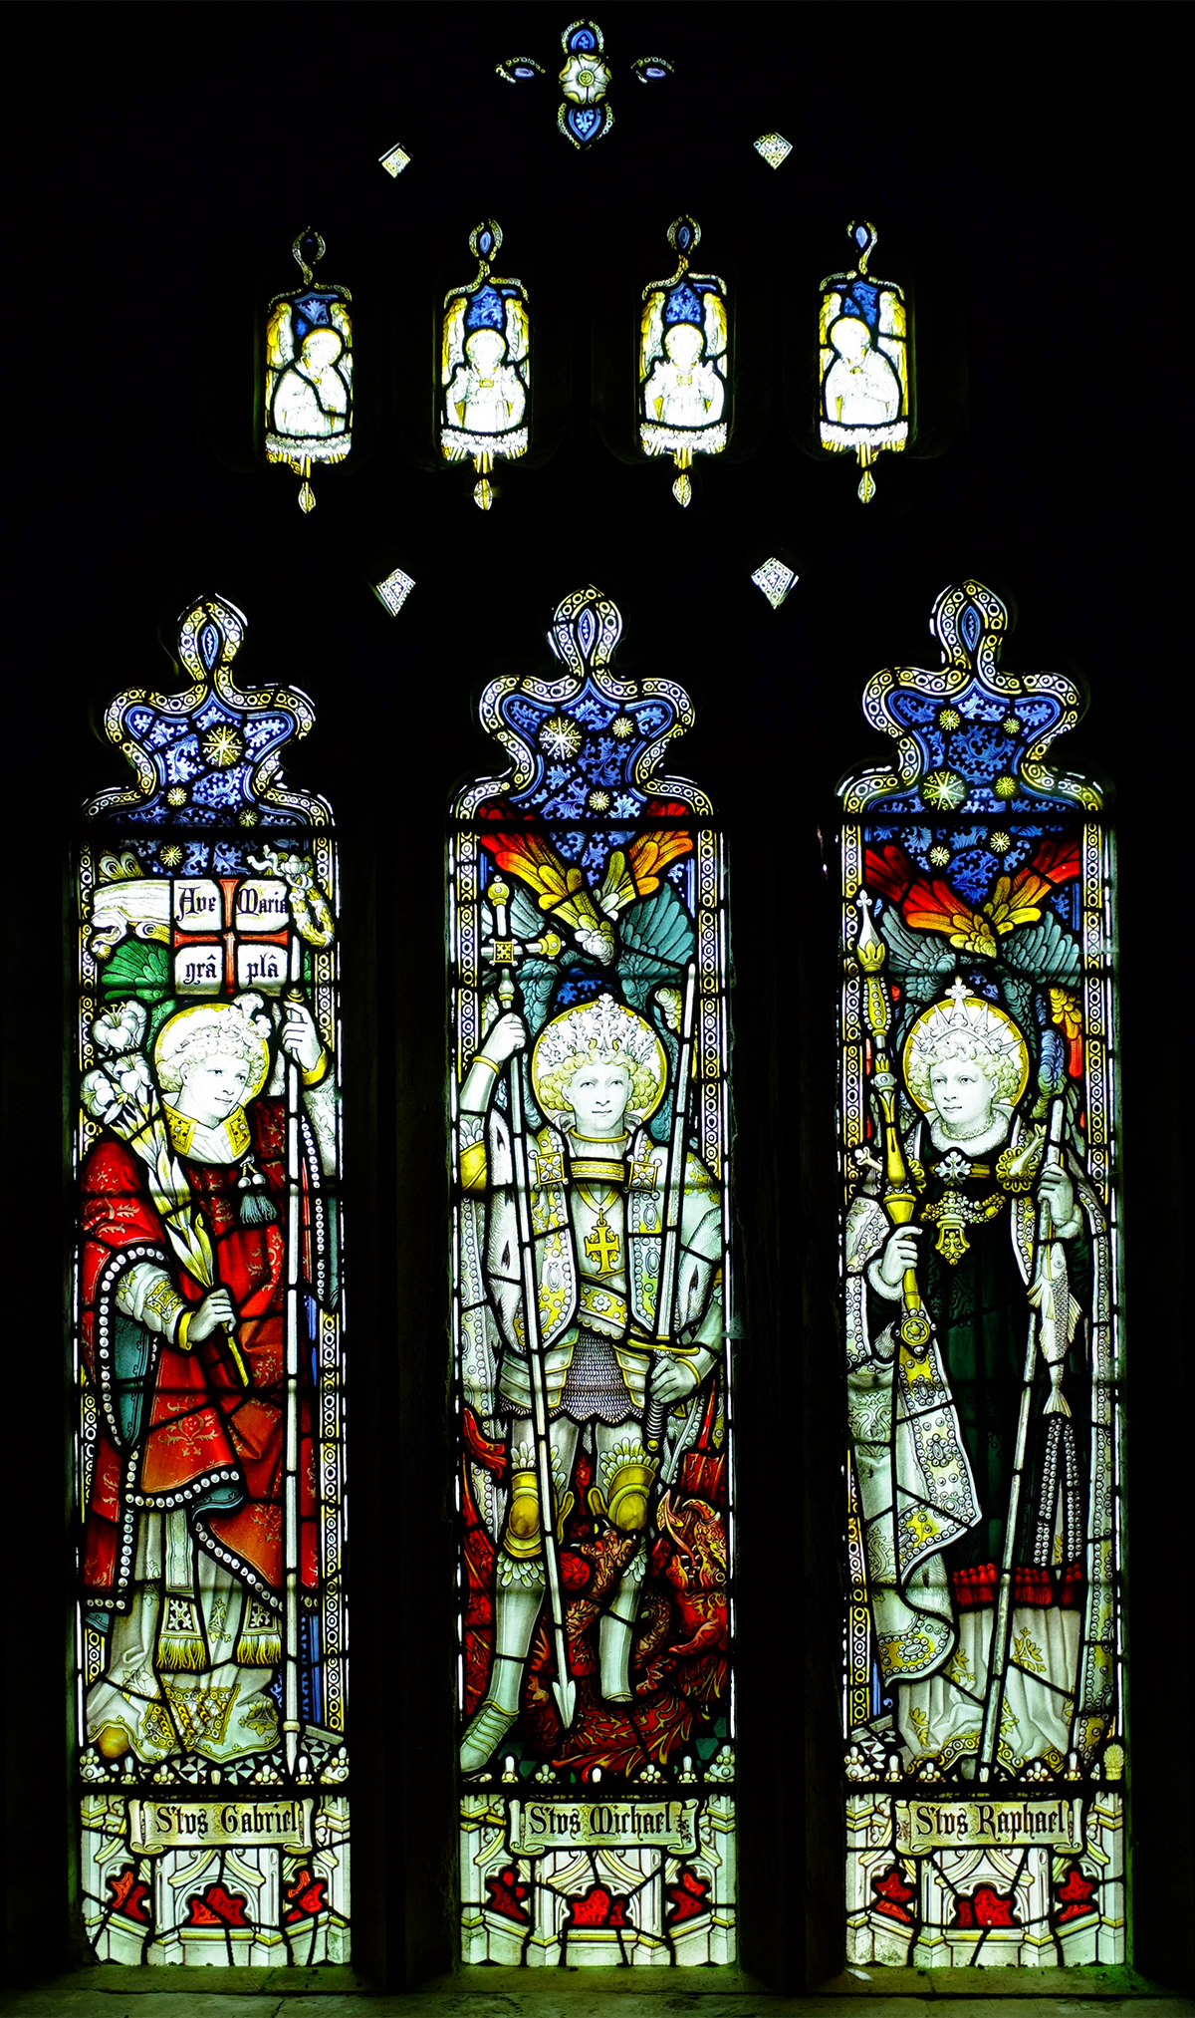
Newsletter Autumn 2018
Volume 10 Issue 2

Cover photograph of the Tower Window courtesy of Mr David Goodwin JP
A very fine Archangel window given in memory of William Rowe, late of Sanctuary and Churchwarden at St. Andrew’s Church, Stratton, who died in 1901. The window was inserted in 1906 as a donation from his daughter Miss Rowe. It had been made by C E Kempe and is signed with the wheatsheaf.
NB The detail of this window is rarely seen due to its position high up on the west side of the tower.
Dear Friends,
May I begin by offering my grateful thanks for your tremendous support over the last year - your contributions to the Friends of St Andrew’s really does make a huge difference. I can honestly say that St. Andrew’s Church and its surrounding church yard are kept in the best possible condition thanks to your help.

The summer period has been its usual hectic round of services, not to forget the brilliant Flower Festival, and the magnificent Summer Fete. This year we have begun a new tradition in the form of an auction which not only raised the profile of St. Andrew’s in the community but also raised some much-needed finance.

The alterations to the back of the church has moved on a pace. The font has been repositioned so that it is the first thing you see when you enter the church. This reminds us of the fact that our baptism makes us part of the community of faith. The second phase will be the removal of the pews at the rear of the church to provide a social area which can be used by the whole community. The final phase will be the provision of a new kitchen which we hope will be completed before the end of the year.

Next year, to mark the tenth anniversary of the founding of the Friends of St. Andrew’s, we intend to celebrate in grand style & Fr David Standen who was part of the group that initiated the Friends’ scheme will be coming to join us.

The latest news from the Diocese of Truro is the appointment of our new Bishop the Revd Philip

Mounstephen who will be consecrated bishop later this year and will take up his post as Diocesan Bishop early in the new year. He says “I am absolutely delighted to have been called to lead the Diocese of Truro in mission and ministry. With my family roots in Cornwall I am very well aware of what a rich Christian heritage we have. I rejoice in Cornwall’s strong sense of particularity and identity and look forward under God into leading us in what I hope and pray will be a fruitful and exciting future.”

Once again, I offer my grateful thanks to you all for continuing with your support without which St. Andrew’s would be a poorer place.

Fr. David
_______________________________________________

Val Barker writes:

In the last News Letter I wrote about change and that theme has continued to some extent but at long last there are signs that things should be more settled in the near future. At least we shall know where we stand and what is, and what is not, possible in our worship life and day to day organisation within the Benefice and Deanery. As ever we remain positive about the future and even more hopeful with the news that the 16th Bishop of Truro will soon be here amongst us. As Fr David has already said, The Revd Canon Philip Mounstephen will be consecrated as bishop later this year and we shall look forward to welcoming him to Cornwall soon after.

Regarding FoStA - fundraising has gone very well lately thanks to a number of very generous donations and a successful auction at the end of August. It was Phyllis Barnard’s idea and it came to fruition with input from all the committee members and three other Friends who volunteered their help. The auctioneer was Mr Reg Hambley, from Kilkhampton, and he, with the help of his daughter and son-in-law, made the whole event entertaining and great fun as well as financially successful. We are grateful to all those who gave items and all those who came and supported us on the day.
Earlier in the year the Trustees of the Devon and Cornwall Record Society came to St Andrew’s for the launch of a new book – Stratton Church Wardens’ Accounts 1512 – 1578 edited and with an introduction by Joanna Mattingly. Not many church accounts survive from that period but ours are almost intact and are well preserved. In addition Stratton has a partial set of general receivers’ or Stock Wardens’ Accounts, which are in the British Library and at Cornwall Records Office. All these records have been transcribed to form this book and it makes fascinating reading. It was a very good event with an interesting presentation by Dr Mattingly to a large audience and after the event FoStA were in receipt of a generous donation from the Society.
As I said last time we needed to think about how to make the Friends’ 10th anniversary a really special celebration and we seem to be getting there. The committee have thought long and hard about what we should/could do and have come up with some definite ideas with the agreement of Fr David Barnes and the PCC.

Firstly we decided that we needed to ask someone to be our Honorary President and we would have a dinner with a guest speaker and culminate proceedings with a Thanksgiving Mass on the Sunday.
It was an easy decision as to who we should ask to be President – the one who had been enthusiastic about the idea of the scheme in the first place and had gone on to support and encourage the original small committee through his high level of involvement. The Revd Dr David Charles Standen – who better? I asked him and he agreed. He has also said that he will come to Stratton for the weekend and be fully involved in the celebrations. Do put the dates in your diary (24th and 25th May 2019) and before long you will be receiving your invitations and information regarding the weekend.
Will look forward to seeing you there.

So now it just leaves me to say a huge Thank You, as always, for supporting the Friends of St Andrew’s. Your consistent and loyal support is humbling and we are forever grateful.

With the best of wishes from us all at St Andrew’s.

Val


In Memoriam
One of our founder members and sponsor, Mrs Coral Barbara Forshew died on Easter morning, 1st April 2018.
A service of celebration for her life was held at St Andrew’s on the afternoon of Tuesday 1st May.

Coral was well known in the area and had been involved with many local organisations and will be remembered for her philanthropy, generosity and commitment to many causes. She was a regular communicant and St Andrew’s was very important to her. Her interest, in all things Stratton, never waned or diminished and she will be missed by all who knew her.

We offer sincere condolences and our prayers to her sons Nick and Adrian and all the family.
May she rest in Peace.
_______________________________________________
Developments for the Rear of St. Andrews – The Project Begins
After so much time spent planning the changes to the back of the church, and in obtaining the necessary approval from the Diocese, it was very exciting to be at last able to make a physical start to the project.

It was in the week after Easter that the builders arrived to commence Phase 1, which comprised the relocation of the font from the west to the east of the main entrance door, thus opening up the space in the south-west corner of the Church.

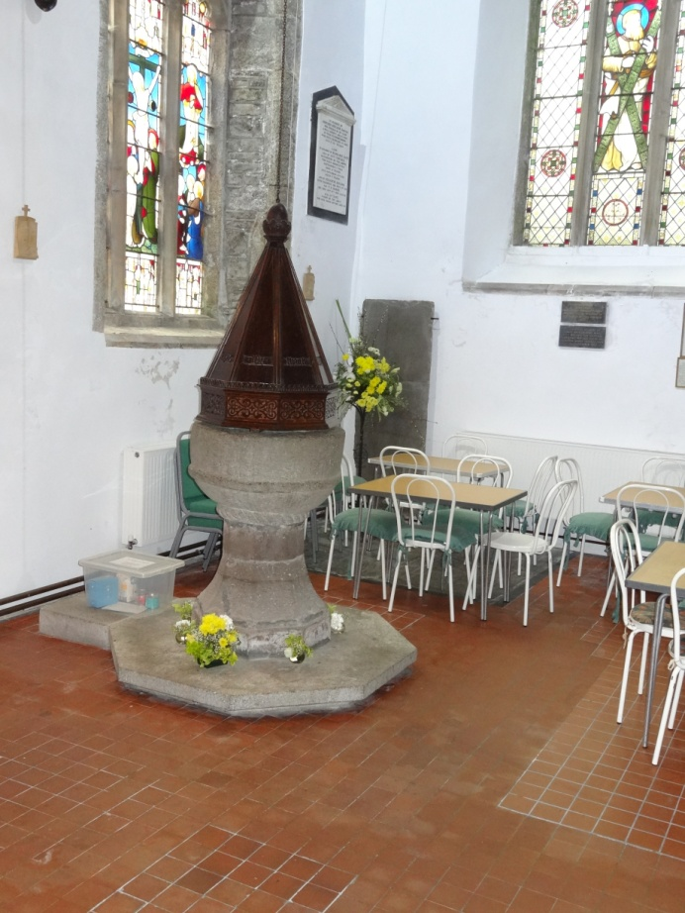
The font and south-west corner of St Andrews before the work commenced, showing the cramped space for tables and chairs and the trip hazard resulting from the stone plinth.

To make way for the relocated font it was necessary to remove three rows of pews from the rear of the south aisle, although the rear pew, being of historic interest, had to be retained, and so four rows of pews were actually removed and then the historic rear pew repositioned further forward. In addition it was necessary to remove the raised platform under the pews to allow the floor around the repositioned font to be brought level with the surrounding floor and tiled to match. It was also decided to sink the stone plinth of the font to be flush with the floor, thus removing the trip hazard. The final task was to make good and tile the area from where the font had been removed.
Our one major concern before work commenced was what would be found under the floor when the raised platform was removed, particularly any burial remains, which is always a possibility in an historic church. In the event, the only bones found belonged to a long deceased rat.

With the pews removed the builders decided to reposition the font canopy first, the logic being that it would be more straightforward to position the font to suit the canopy rather than try to hang the canopy to suit the font. The font was then disassembled into three parts for moving – the bowl, base and plinth – and put back together in its new position.

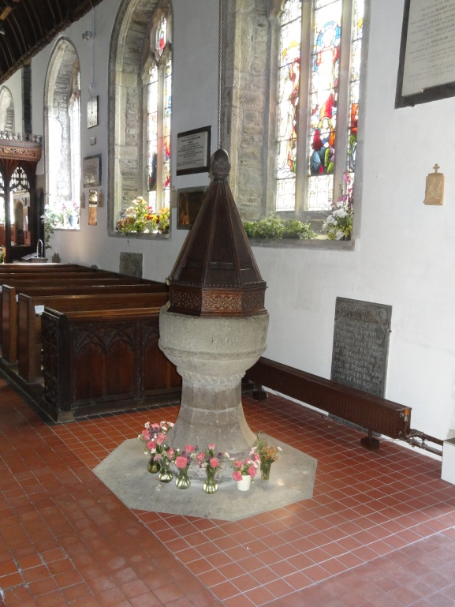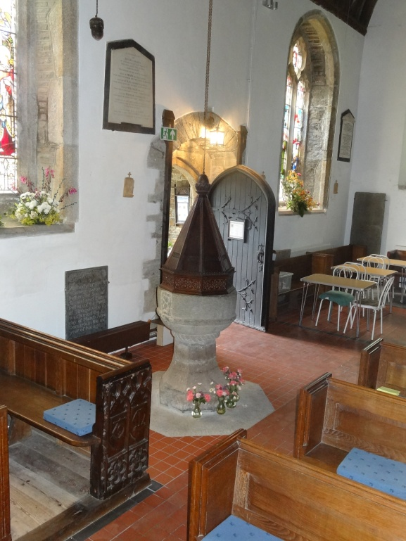
Views of the font after completion of works.

Thanks to the proficiency of our builder and carpenter the project ran very smoothly with no significant hiccups, and was completed within our budget for this phase of the work. The historic pew, re-assembled in its new location, looks as if it has always been there, and the flush plinth around the font has worked well and is considered much safer during baptisms. In fact the general feedback has been very positive, with most people commenting that they feel the new position for the font is much better. It seems appropriate that the font is the first thing seen on entering the church, rather than it being tucked away behind the door.
The improved space in the south-west corner has also already proved successful, and good use was made of this area during the flower festival and other social and fund raising events. This gives confidence that overall plans for the back of the church will be beneficial for the future use of the building.
The next phase of the project will be the removal of pews from the rear of church to open up this space for a more flexible use. The success of our fundraising to date, including a grant of £1,150 from the Allchurches Trust Fund, has now allowed us to go ahead with this work, which is due to commence towards the end of September, for completion before our next big fundraising event, the Craft Fair, at the end of October.
However, based on our current estimates, we still require a further £10,000 in order to go ahead with the final phase, the relocation of the vestry and installation of the new kitchen. We continue to hope that this can be completed before Christmas, but this will be dependent on the success of other outstanding grant applications.
Simon Waring, Churchwarden
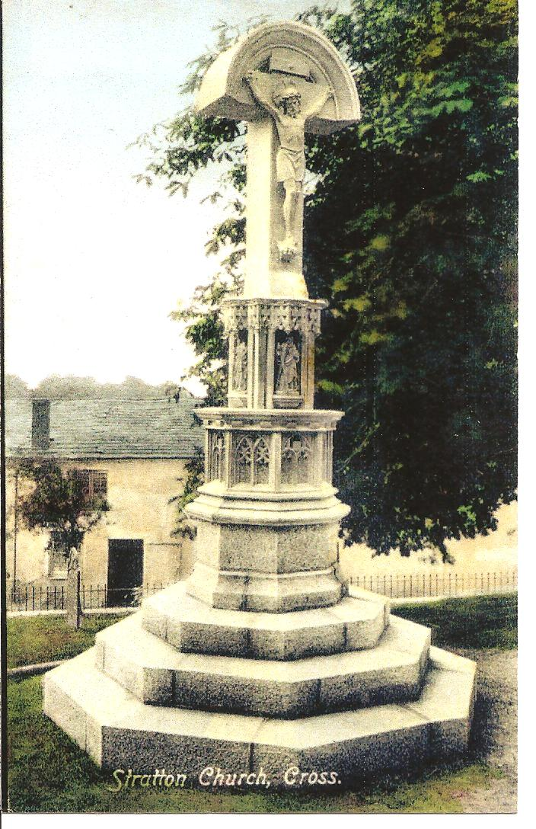
The Calvary Cross (Update)
I have been to the Cornwall Records Office and spent some time going through the PCC minutes of the years from 1941 – 1947. Luckily the reports are rather shorter and more succinct than those written by our present secretary but it did give rise to a great many unanswered questions and I was left thinking it would have been good to have more detail!
In a minute in the Stratton Parish Church PCC minutes dated 23 January 1942 it states: ‘Wingate Memorial. It was resolved that the figures now crumbling away and unsafe be removed by Mr Roberts of Bude.’ Signed C V Lawson, Vicar.
In January of the next year it was agreed that Mr J C Parkhouse (Builder of Bude) would remove the stone which was then to be placed in a spot somewhere convenient in the churchyard. (We have no knowledge of where this ‘convenient spot’ might have been and there is no evidence that any part of the original bath stone carvings exist today.)
No further mention is made of the carvings but there are several notes regarding the wooden crucifix that was eventually fixed to the original base. This was ordered from G Maile and Son Ltd of London and it appeared that they were rather long winded in their manufacture and this fact caused a great deal of anxiety as well as cost, the latter, yet again being mostly covered by generous donations from parishioners.
As I have mentioned before the new Calvary Cross was finished and in place by the end of 1950 & re- dedicated within the octave of the Patronal Festival.
Ed
_______________________________________________

KEEPING UP-TO-DATE and WITHIN THE LAW
To make sure that FoStA is compliant with the latest regulation in EU law – the General Protection Regulation (GDPR) which came into effect on 25th May 2018 - we are obliged to advise you of the information we keep and give you the option to have your information deleted and to be no longer contacted by us. In order to keep your details on our database we have to ask for your consent to do so.
You will see our Data Information Statement printed within this Newsletter and it may also be seen on the FoStA website - www.fosta.org.uk
A consent form is enclosed and this needs your positive action. Please be kind enough to complete it as appropriate and, at your earliest convenience, return it in the supplied, stamped addressed envelope. Thank you.
Ed

The Friends of St. Andrew’s Church,
Stratton
Privacy Information Statement
FoStA holds data, supplied by its members on application to join the scheme. It may include an e-mail address as well as title, full name, postal address and telephone number. This information is stored on a computer which is protected by a password known only to the Membership Secretary and a named deputy (for emergency use only).
The data is used to administer the business of FoStA and for sending out relevant documentation to its members. This information is not shared with any other organisation or member and is kept until the membership lapses or a member resigns. It is then deleted from the records except in the instance where a Gift Aid mandate has been signed as then the data has to be kept for 6 years, from the date of the last claim, as required by law.
Any member can gain access to his/her own personal information held by contacting the Membership Secretary at Chynoweth, Bowden, Stratton, Bude, Cornwall. EX23 9BH or e-mail memsec@fosta.org.uk Members also have the right to withdraw their consent at any time by contacting the Membership Secretary at the above address. The data stored is only that which is collected from the member. Members are therefore encouraged to inform the FoStA Membership Secretary of any changes to their postal address, e-mail address or telephone number so that we can remain in contact.
YOUR NEWS, VIEWS and COMMENTS:
I did notice the work that Michael Vanstone & his team had done to the pathway – excellent and meticulous as always. We are also delighted to hear that the old stones will be used at the top of the graveyard and not disposed of. John Wickett, Poughill
I do so appreciate the Newsletter and the contact. It keeps me feeling in touch with so much of my life… Jonathan Howlett, Scotland.
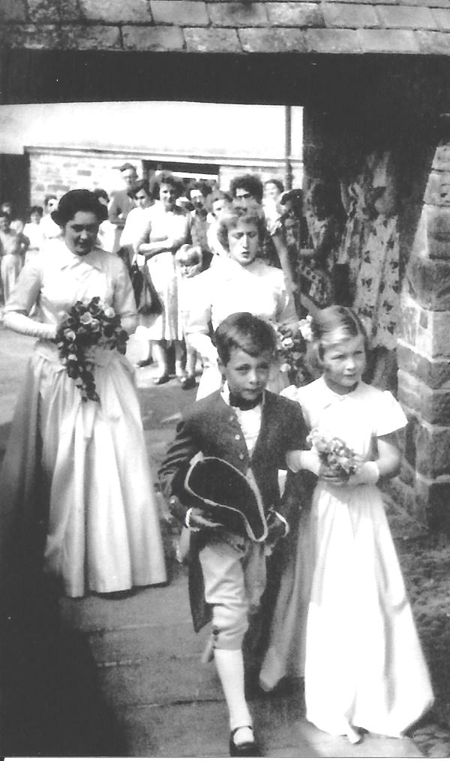
Thank you for the latest Newsletter – an interesting read.
I attach a photo of myself with bridesmaids coming through the Lych Gate, at St Andrew’s, for Biddy Martin’s wedding 26th August 1955. I was under strict instructions to look after the girls particularly the younger one. I felt very protective of her - even had a ceremonial sword for the purpose! - which you can’t really see in the picture but you can see the smart tricorn hat that I am carrying. Nice to see everyone standing outside to watch. Mark Cardale, London
This was a Naval wedding and I have heard the story many times as to how the best man and a couple of other young naval officers scaled the tower and then abseiled down the night before the wedding – just for a lark! The groom will be fondly remembered as the Revd Donald Young, OBE RN, who helped us out considerably in the early 1980s during his retirement. Does anyone know any of the people in the photograph? If you do please let me know. Ed
_______________________________________________

Dates for Your Diary

- Saturday 27th & Sunday 28th October 2018 FoStA Craft Fayre in the Church 10am to 4pm
- Sunday 25th November 2018 Patronal Festival Celebrations
- Saturday 1st December 2018 Gift Day
- Saturday 25th & Sunday 26th May 2019 Friends Weekend of Celebration and Thanksgiving All details in due course

The online monthly calendar is kept up to date by our Web Master with services and events so do check for further details at www.fosta.org.uk

* * Items for Sale * *
Christmas Cards
Please consider buying some FoStA cards this year. We still have some stock from previous years and also a new one. We were fortunate in that David Goodwin was at home when Stratton experienced some snow early in the year and the result is a beautiful Christmas card with a type of view rarely seen. It has been produced in a larger size than we usually have and I think you will agree that the result is extremely pleasing.
For other items please see the ‘FoStA Shop’ online.

FoStA Newsletter is published by
St Andrew’s Church, Stratton, Cornwall. EX23 9DW
Members are sent a copy by post and
a PDF version is available on the FoStA web site - www.fosta.org.uk

Parish Priest: Father David Barnes
1 Lanvean, Cleavelands, Stratton, Bude. EX23 8LJ
Tel: 01288 352254 e-mail: d.barnes645@btinternet.com

Newsletter Editor: Mrs Val Barker
Chynoweth, Bowden, Stratton, Bude EX23 9BH
Tel: 01288 353435 e-mail: memsec@fosta.org.uk

** In future, if you are prepared to view the newsletter on line or print it yourself, please let me know. **

