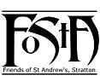
Friends of St Andrew’s Church
Stratton, Cornwall
Newsletter Spring 2017
Volume 9 Issue 1
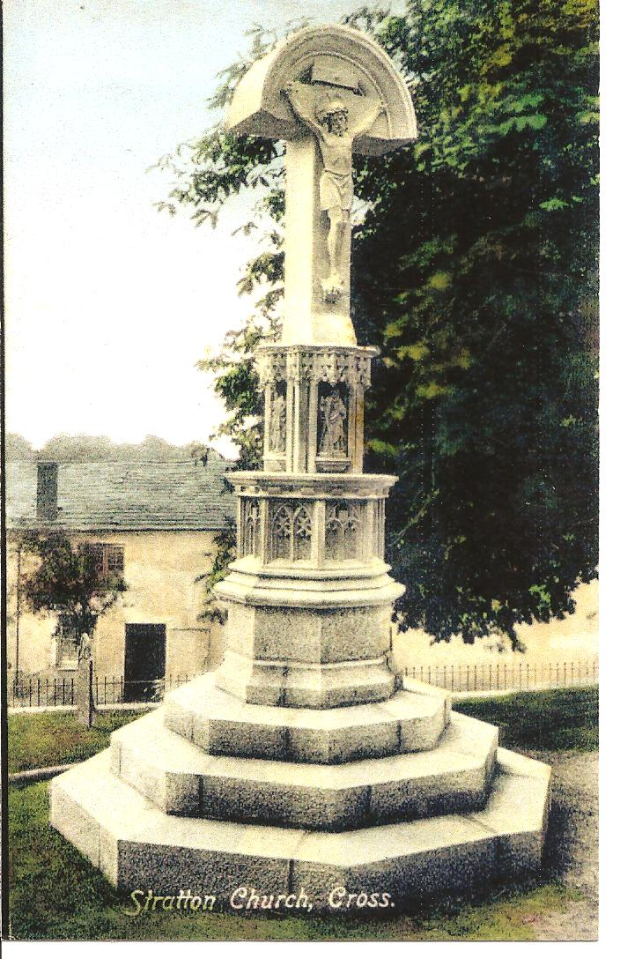

Dear Friends of St. Andrews,

Since last I wrote we have celebrated that great and glorious feast of Christmas. St. Andrew’s Church looked magnificent, with its wonderful decorations and flowers befitting the season. The altar had been turned around and opened up to provide a stable setting to enable a back drop for the nativity figures. The poignancy of the setting is best expressed in that anonymous poem that speaks of the shepherds stooping low and being able to stare level eyed into the face of God. As communicants at the altar rail we too were able to share in looking into the face of God. During the whole of the Christmas and Epiphany season we were able to look back at the scene and remember the great feast of the incarnation, the time when God became man.

Throughout the Christmas period the Church celebrated the Nativity in many different ways, from the Primary School concert, 9 Lessons and Carols, to the Christingle service and the traditional Midnight Mass and Christmas morning service. The various styles of service attracted many people from the town and all seemed to enjoy what they had been part of. The school’s carol concert was a well organised and deeply meaningful act of worship which was well led by the children. Their depiction of the Nativity and their singing was a great credit to the school.

As the Church moves into Lent, the inside of the Church will start to look a little austere with the removal of flowers and decorations. This is to mark a time of penitence and reflection in readiness to celebrate Easter. Although the Church will be lacking the beauty of flower arrangements the outside grounds of the Church are beginning to be adorned by early spring flowers, making the paths up to the church a veritable kaleidoscope of colour.

No matter what time of the year St. Andrew’s Church is always a warm, welcoming and hospitable place. Its fabric and décor are always a credit to those who work so hard to keep the church, not only in a good state of repair but also enable it to be a place worthy of the worship of Almighty God. I would like to offer my grateful thanks to all those who work so tirelessly and those who support financially in making St. Andrew’s Church a beacon of light and hope in the parish of Stratton and beyond.

Fr. David

Val Barker writes:

May I add my thanks, to those of Fr David, to all of you who continue, faithfully, with your support of FoStA.
We ended the year 2016 in an improved financial position thanks to all the membership subscriptions, donations, FoStA shop sales and fundraising activities. The Craft Fair run by Kim Gouldson and Lyzette Bevan was a particular success raising a total of £1,556. The PCC have several projects and maintenance jobs in the pipeline so hopefully we will be able to continue with our support and grant aid.
With every good wish from us all at St Andrew’s. Val
The Calvary Cross at St Andrew’s.

Although not so much time is spent these days going through the old church records, the draw is still there and I have continued to keep adding to the St. Andrew’s ‘Time Line’ which was started many years ago and, to date, goes from 1086 to the present day. It comprises many aspects of church life through the years and as I collect some new gem of information I attempt to illustrate it in some way – a photograph, newspaper article or similar. It is a bit like Family History research – one gets hooked!

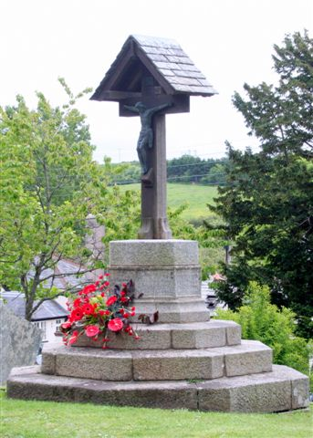
You will have noticed on receiving this spring issue of the newsletter that the picture on the front has changed yet again. It shows the Calvary Cross which was positioned just outside the South Porch of St Andrew’s and looking considerably different from the one that is there today. This type of cross represents the Hill at Calvary where Our Lord’s crucifixion took place. It is traditionally built on three steps (as ours is) and symbolically, in descending order, represents Faith, based upon Hope, based upon Love. A Churchyard Cross (as they are sometimes known) also serves as a communal memorial over all the graves and reminds visitors that they are on holy ground.
Our monument is a memorial to a one-time Parish Priest here in Stratton – the Revd. George Wingate; instituted 1892 and who died December 16th 1898 aged 52 years of cancer of the hip.
A newspaper cutting in the archives reads as follows:

STRATTON – Dedication of a Churchyard Cross.
A unique event in the history of St Andrew’s Church, Stratton, was that of Wednesday (June 30th 1906) when there was dedicated a churchyard cross, a memorial to Rev George Wingate M.A., presented by Mrs Wingate. Holy Communion was observed at 8 and 10am, a public tea in the Church Room at 5pm and dedication service at 7pm by the Bishop of St Germans.
The Cross, of Gothic Style, stands 11 feet high. The base is of granite and upper carved part of Polyphant stone. The tracery is very fine. There are figures of S. Andrew, S. Peter, Moses and Simon of Cyrene, each with a cross surmounted by the crucifix. The work was ably carried out by Mr Nicholls of Polyphant, from a rare design by Mr Sedding. The church bells were rung during the afternoon.
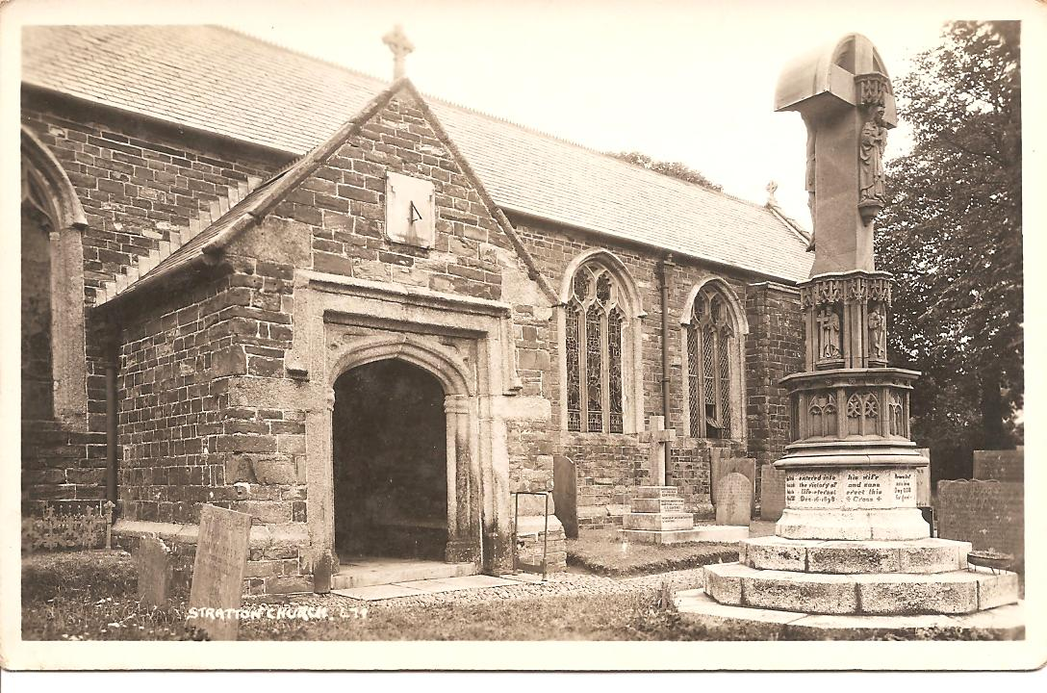

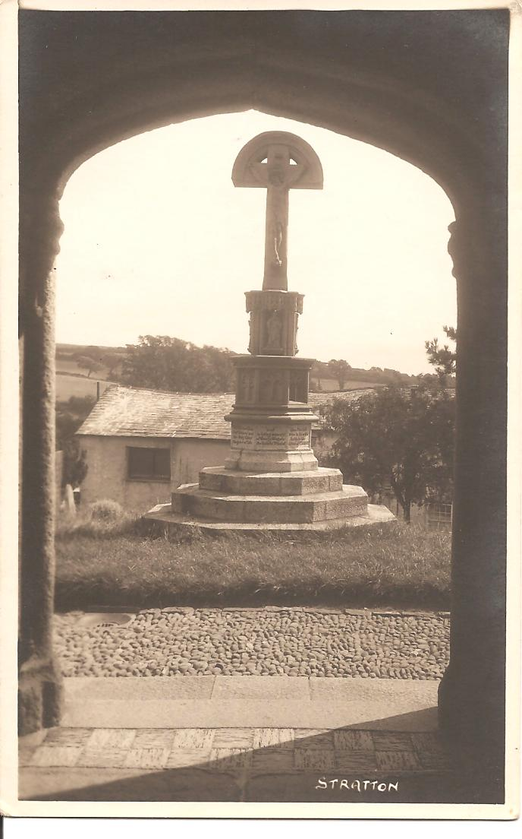
It is not easy to see from these photographs but the cross is very interesting in that the figure that faced the church door is Christ Crucified whereas the figure facing south on the other side is Christ the King. Perhaps all the symbolism of the original cross gives a clue as to why it was replaced by something much simpler or perhaps it was damaged in some way.

In any event, at sometime between 1906 and 1947 the cross disappears – no one seems to know exactly when.

The first reference to the cross we have now is in the Newsletter and Broadsheet of the Parish Church of S. Andrew, Stratton written by the then Parish Priest Fr Tom Gilbert in May 1947.

In his letter he writes:-

We often get enquiries as to the Churchyard Calvary outside the South Door. The order was given for its re-erection some years ago and part of the cost has already been paid…
And then in his letter in June 1947:-
You will all be glad to know that at long last there is every hope that the Calvary in the Churchyard is soon to be re-erected: the trouble has been Government restrictions of suitable teak wood. We have been assured that hard seasoned oak is equally suitable, and as this is available we have accepted the firm’s suggestion that they proceed with the work immediately. They hope to have the Cross completed and ready for despatch early in July.

In February 1948:

At long last the Wingate Memorial Cross has arrived…

March 1948:

We hope very soon to see the Churchyard Calvary re-erected: the re-erection alone will cost us approximately £60, so that the Church Council thought it wise to place on record that while they are glad to complete the re-erection of the Wingate Memorial, they do not feel that this should be a charge on the Parish for all time.

The Wingate Memorial was finally re-erected and dedicated on Sunday December 5th 1948.

So, it looks as if I need to go to Truro and search the records for more information about what happened to the original Cross and as for the wooden one being a charge on the Parish; Mike Worden has repaired it on at least two occasions to my certain knowledge and no one has ever complained about the cost.
Val Barker

P.S. If anyone has any ideas about the mysterious disappearance of the original Calvary Cross do get in touch.
Obituary
Michael Peardon Worden
Mike Worden, a much respected and well-known local man, died at Stratton Hospital on 28th December 2016 and the funeral service and celebration of his life took place at St Andrew’s Church on Saturday 7th January 2017.
The funeral address was movingly given by his son-in-law, Geoff Day, and Mike would have approved – it was laced with anecdotes, humour and sheer nostalgia. The opening introduction was indicative of what was to come:
‘Mike was born in Hillside Cottage, Spicers Lane, Stratton on the 7th January 1932. Hillside is about 50 yards away from where he is about to be buried and as today is his birthday he would find it amusing that in exactly 85 years he has travelled just 50 yards. He was, of course, a very proud Cornishman and also especially proud to have been so intimately a part of this lovely town and church.’
Mike Worden was dearly loved by all his family and many friends, both near and far, and will be sorely missed. He was such a good, true and loyal Friend to so many of us. We offer our condolences and prayers to his daughters and the whole family.
May he rest in peace.

FoSTA Fundraising Dinner
On Saturday 22 December Anne and Geoff Day welcomed 12 Guinea pigs to their home for a new kind of fundraising dinner. The tickets for this event had sold like hotcakes and everyone present was very excited by the idea of a gourmet dinner in which each course was matched by a pair of different but complementary wines. The three-course menu had been devised by David Goodwin and Anne Day who were also responsible for the preparation and serving of the food and wines. The idea was to have an event which as closely as possible provided a restaurant-style experience with a commentary on the wines from David as the evening progressed.
David had worked closely with his wine merchant at Corney and Barrow who gave expert advice on the wine matching and supplied the wines at a generous discount as it was for a good cause.
The evening started with a sparkling apéritif (Blanc de Blancs) which enabled everyone to relax and get to know each other. The first course was potted haddock which was paired with white wines from France (Burgundy) and Spain (Albariño). The main course was Navarin of Lamb – a classic French all-in-one brasserie dish - paired with red wines from France (Madiran) and Italy (Piedmont). The apple and orange tart dessert was paired with sweet wines from France (Rhône) and Italy (Piedmont).
Everyone agreed that it was an event worth repeating and a very pleasant way of raising funds for FoSTA which received £261.16 after expenses.
An excellent evening all round. I can vouch for it! Ed
Projects Update
Besides enabling our many friends to maintain their connections with St Andrew’s, one of the important aims of FoStA is to raise funds for the purpose of contributing towards the costs of repairing and maintaining the church building and churchyard. Funds are raised both from the annual subscription of members and the many fundraising events that take place throughout the year. The FoStA committee are therefore very pleased that recently they have been able to offer grants to the PCC to meet the costs of two significant projects for much needed improvements in and around the church.
The first of these was for lighting improvements within the church. The existing lighting had been installed in spring 2010, with new fittings and energy saving lamps replacing obsolete lamps and worn out fittings. This installation provided a vast improvement to what had been there before and in general continues to give a good level of lighting in most areas of the church. However, it had long been felt that the north and south aisles appeared dull compared with the rest of the church and following redecoration of the walls early in 2016 this situation did not improve. In addition, although the nave lighting was generally good, the area in the very centre from which the Gospel is read was less satisfactory. A quotation was therefore obtained for six new LED spotlights to illuminate the walls of the aisles, and for another in the nave to focus

light on the Gospel reading position. The FoStA committee agreed that this was a project that it would like to support. The work was carried out at the end of 2016, and this has resulted in a significant improvement with many favourable comments.
The second project relates to the path from the Lych Gate to the West Door. Over the course of the years, several sections of the path had become uneven and now presented a trip hazard, and also the existing slabs became very slippery in wet weather. Safety was therefore becoming a major concern. In addition, the narrow width of the central paving slabs with the cobbled borders on either side made wheelchair access difficult and uncomfortable. The agreed solution was therefore to relay the path using paving slabs that provide better grip in wet weather, and at the same time to take the opportunity to reduce the width of the cobbled edging to give a wider central path more suitable for wheelchair use. Once again the FoStA committee felt this was a suitable project to support and offered grant funding. A Faculty has now been obtained for this work and quotations received. The work is due to be carried out in March and will hopefully be complete well before Easter.
The FoStA committee and the PCC of St Andrew’s Church are extremely grateful for the generosity of the FoStA membership which has made these projects possible.
Simon Waring. Churchwarden

In Memoriam

Mrs Pauline Bastin who died on 11th August and whose funeral service & cremation took place on 2nd Sept. 2016. Pauline had been a regular member of St Andrew’s for many years until ill health prevented her attending services but she kept up a keen interest in the church and all that was happening within the community of Stratton. Donations in her memory were kindly given to the Friends of St Andrew’s at the request of her family.

Mrs Margaret Smale who died on 24th December 2016 was laid to rest, as was her wish, in St Andrew’s churchyard on 10th January 2017. Margaret had travelled extensively during her early married life but had lived, for many years, in Stratton where she involved herself in the local community both professionally and as a very willing volunteer. Donations in her memory were given, at the family’s request, to FoStA.
We are grateful to both families for their thoughtful generosity and offer them our condolences and prayers. The loss of these loved ones will be keenly felt by their families and many friends.

Dates for Your Diary

- Friday 26th to Monday 29th May Flower Festival at St. Andrew’s with the theme STRATTON - Faces and Places
- Saturday 17th June
Stratton Summer Fete at Long Paddock, Stratton
Although these events are not specifically for FoStA funds I know there are many of you who will wish to put these dates in your diary.

FoStA Newsletter is published by
St Andrew’s Church, Stratton, Cornwall. EX23 9DW
Members are sent a copy by post and
a PDF version is available on the FoStA web site - www.fosta.org.uk

Parish Priest: Father David Barnes
1 Lanvean, Cleavelands, Stratton, Bude. EX23 8LJ
Tel: 01288 352254 e-mail: d.barnes645@btinternet.com
Curate: Revd Alison Hardy
Newfield, Brook Drive, Bude. EX23 8NY
Tel: 01288 488308 e-mail: reverendalisonhardy@gmail.com

Newsletter Editor: Mrs Val Barker
Chynoweth, Bowden, Stratton, Bude EX23 9BH
Tel: 01288 353435 e-mail: memsec@fosta.org.uk

** If you are prepared to view the newsletter on line or print it yourself, please let me know.
All photographs were taken from the archives

