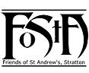
Friends of St Andrew’s Church
Stratton, Cornwall
Newsletter Spring 2018
Volume 10 Issue 1

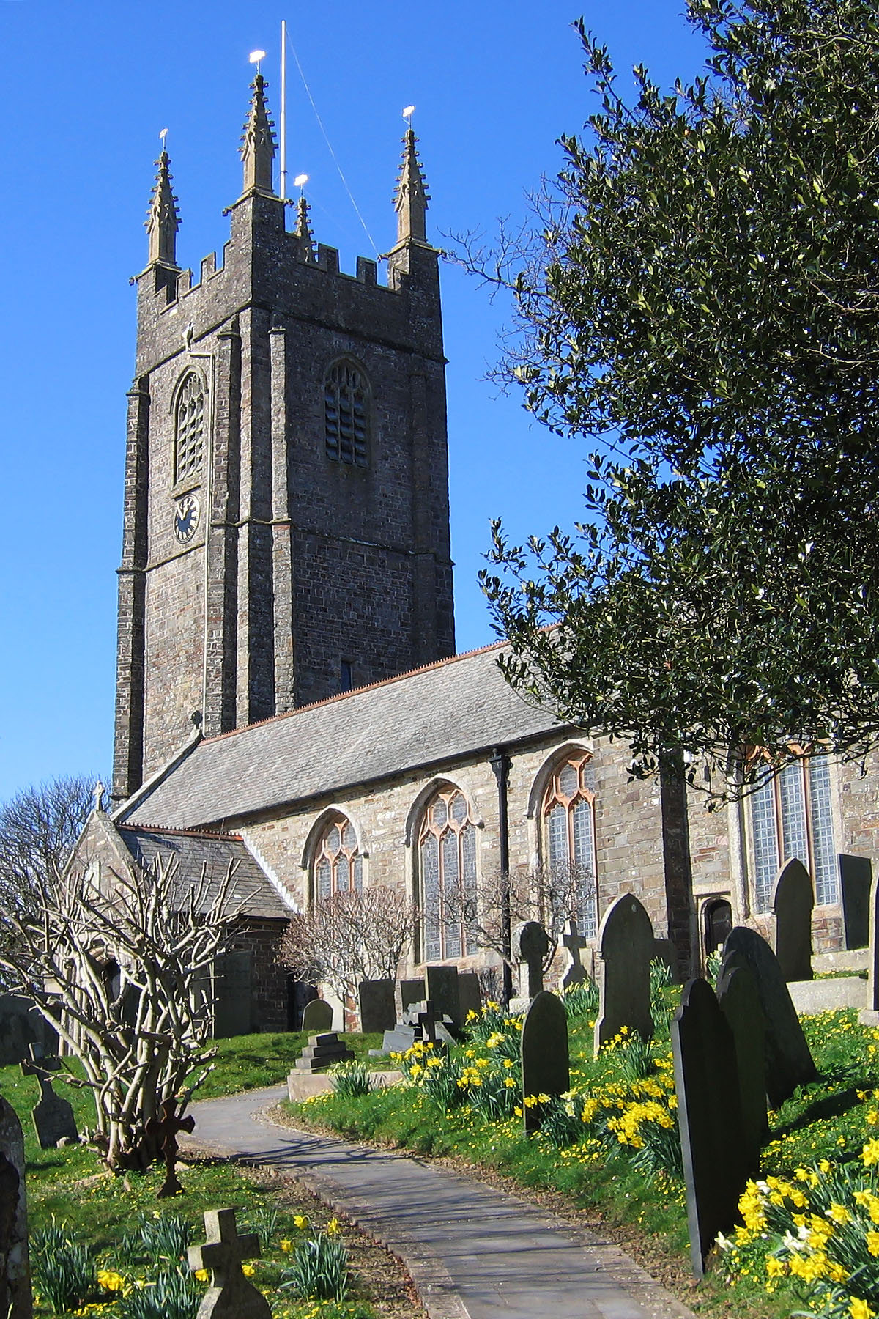

Cover photograph courtesy of Dr Ian Barker
Churchyard photograph courtesy of Mr David Goodwin
Dear Friends of St. Andrews,

I’d like to hope that the majority of the bad weather is now behind us, however there is no guarantee that will be the case.
Since writing to you last, Christmas has come and gone but not without leaving some lasting memories. One of the highlights for me was Stratton Primary School’s carol service which was held in St. Andrew’s with a packed congregation of 300 plus - parents, grandparents and siblings. The choir items and singing were fabulous and the readings of the nativity truly inspirational.
The other church services over the Christmas period were well attended especially the nine lessons and carols and the Christingle service which as usual packed the church to capacity.
A great sadness that has come around is the fact that Sister Alison will be moving on to take her new post as Priest in Charge of the Launceston parishes. Her final Sunday will be the 4th March when there will be a joint service at St. Michael’s at 10.30am. Her licensing will be on the 4th April in Launceston parish church. There is no doubt she will be very much missed by all of us.
As we now move into Lent the church is looking a little austere at the moment, however there is a great and glorious anticipation of Easter, when the church will move from the darkness of death to the light of the resurrection and be decorated with great floral displays.
It will then not be long before we reach the wedding season and the May Bank Holiday flower festival when the church can show forth the glory of God to the world.
May God bless you for all your support.
Fr. David
________________________________________________
Val Barker writes:

The last six months or so at St Andrew’s has been a very busy and challenging time in so many ways with continuing change and development. Exciting some would say!
Last year the Diocese saw a change with the move of Bishop Tim Thornton to pastures new and now the Vacancy in See committee are hard at work preparing all the necessary documentation and arrangements for the choosing of his successor, with news of him or her, possibly at the end of the year.
As Fr David said in his letter Sr Alison will have left us by the time you read this News Letter. We will miss her terribly! Her motivational skills have been such a positive force for good but she will leave us with a lasting legacy which is sure to help shape the future here at St Andrew’s. We wish her well and she goes with our love and prayers.
We had a considerable amount of feedback from the last edition of the News Letter. All positive I’m glad to say. It makes me feel that perhaps we should have a ‘Comments’ page in future. It would be good to share others’ views and not keep them all to myself. Let me know what you think.
It is hard to believe but by the end of the summer FoStA will have been in existence for 10 years. We started inviting people to join and welcomed our first members in August 2008 with the official launch on St Andrew’s Day. We really need to think about how we can make the anniversary a really special celebration.
As ever, may I take this opportunity of thanking each and every one of you for your continuing support and interest in St Andrew’s and our lovely churchyard. Every donation is gratefully received and all spending is carefully deliberated upon before any grants are given.
Thank you too, to those who have given donations specifically for the re-ordering of the back of the church. It is a huge undertaking and the financial help already obtained has gone a long way to keeping the impetus going and maintaining the spirits of our Churchwarden. He is working extremely hard not only with the project management but also with funding applications. We received an interesting comment from one Friend after she had read Simon’s last article and referred to the re-ordering as…’development plans’ and went on to say… ‘We have been through all that here…took years…and now we wish we had been more radical.’
So, until the next time, enjoy the Spring-time as we will be here in Stratton and I wish you all the blessings and the special joy that Easter brings.
With the best of wishes from us all at St Andrew’s.
Val
As some of you well know, I spend time between editions inviting people to write articles for inclusion in our News Letter. The idea is not only to add interest for the readership but also to encourage members’ contribution and involvement. The following article came from the niece of one of our members and as we remember ‘Christians throughout the World’ in our intercessory prayers each Sunday it seemed just the right thing to include. Many thanks Claire for this very interesting article. Ed

Life in Mostar
I moved to Mostar (Bosnia Herzegovina) in 1998, expecting to spend a year here after finishing my university studies. 19 years later I am still here! I have been hugely privileged over this time to get to know many hundreds of people, to be a part of the local church, and to see the country change and develop.
I came here originally with a British charity, to do youth and humanitarian work alongside the church. I now work directly for the church – I am part of the leadership team and am still doing work with children and young people, aid and development work, and also other outreach and general admin work. I now work with the children of some of the children I worked with when I was first here!
Unlike those in Cornwall, Protestant churches here do not have a long history. The oldest church in the country celebrated its 60th anniversary this year. Our own fellowship, here in Mostar, dates from the 1970s. We meet in the house where a famous local poet was born, the church purchased it from his heirs in 1984. It was in a poor state of repair back then. The renovations were completed in 1990. In 1992 the building was heavily shelled (part of the 1992-1995 war) and almost completely destroyed. 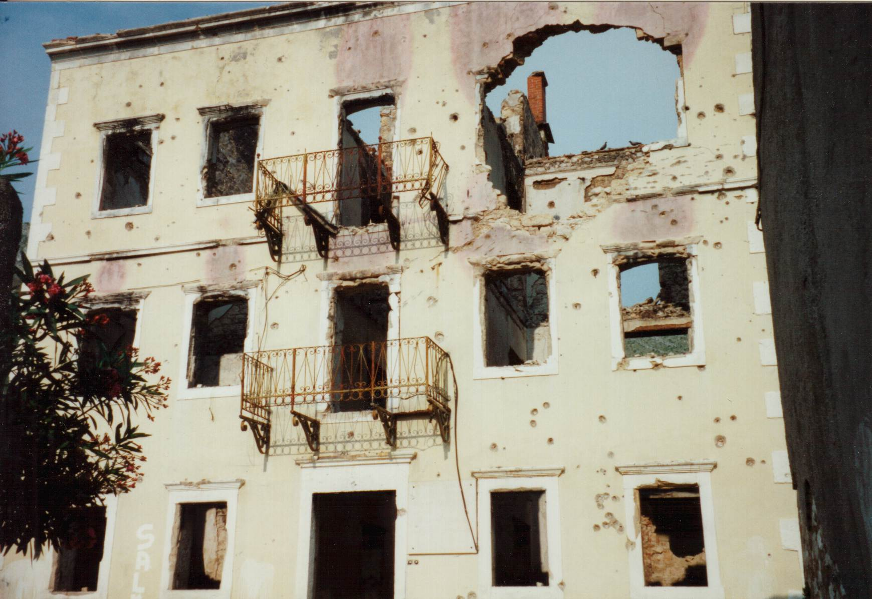
Thankfully it has once again been completely rebuilt.
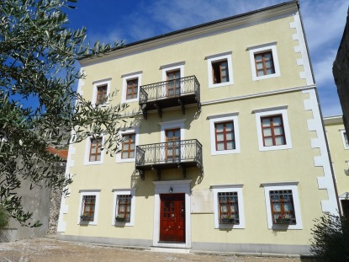
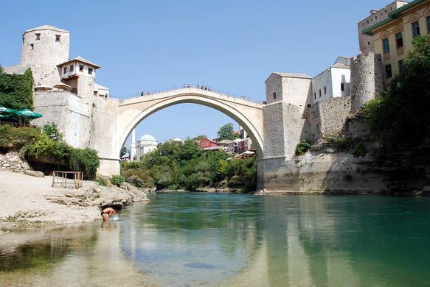
As this building, and many others, including the famous Old Bridge, have been restored during my time here, so I have also seen many other developments: the arrival of cash machines, and instant coffee, the country (which became independent in 1992 – having previously been a part of Yugoslavia, the Austro-Hungarian and Ottoman Empires) got its own bank notes, then coins, then number-plates, the train returned to Mostar, the first supermarkets opened, then the first shopping centres, and finally McDonald's arrived!
Bosnia Herzegovina is an incredibly beautiful country, and the people are very open and friendly. It truly is a lovely place to live. However, it is also a country with many problems. Official statistics are hard to come by but unemployment is around 40%, over 60% for youth. The political situation is incredibly complicated, the economy is in a very poor state, nationalism lurks not very far under the surface, and many people dream only of leaving. Children attend schools divided by nationality (the country is made up of Serbs, Croats and Bosniaks) and many of those I work with still do not have an inside toilet.
The Protestant Church here numbers around 500 believers (in a country of around 3.8 million). We are generally highly regarded – many people had very positive experiences of Protestant Christians while they were refugees in Germany; but we are still very much considered as outsiders. People are born into different religions, dependant on their nationality, and the expectation is that you should never change this allegiance, although mostly it is very nominal. We aim to show Jesus' love to all people, whatever their background, and to show them that He offers true hope for the future. Many of our church activities would seem very similar to those of English churches, but others would not – including cultivating potatoes and cabbages as a means of outreach. However, in all that we are doing, I am incredibly glad to be a part of it.
Claire Gingell
________________________________________________
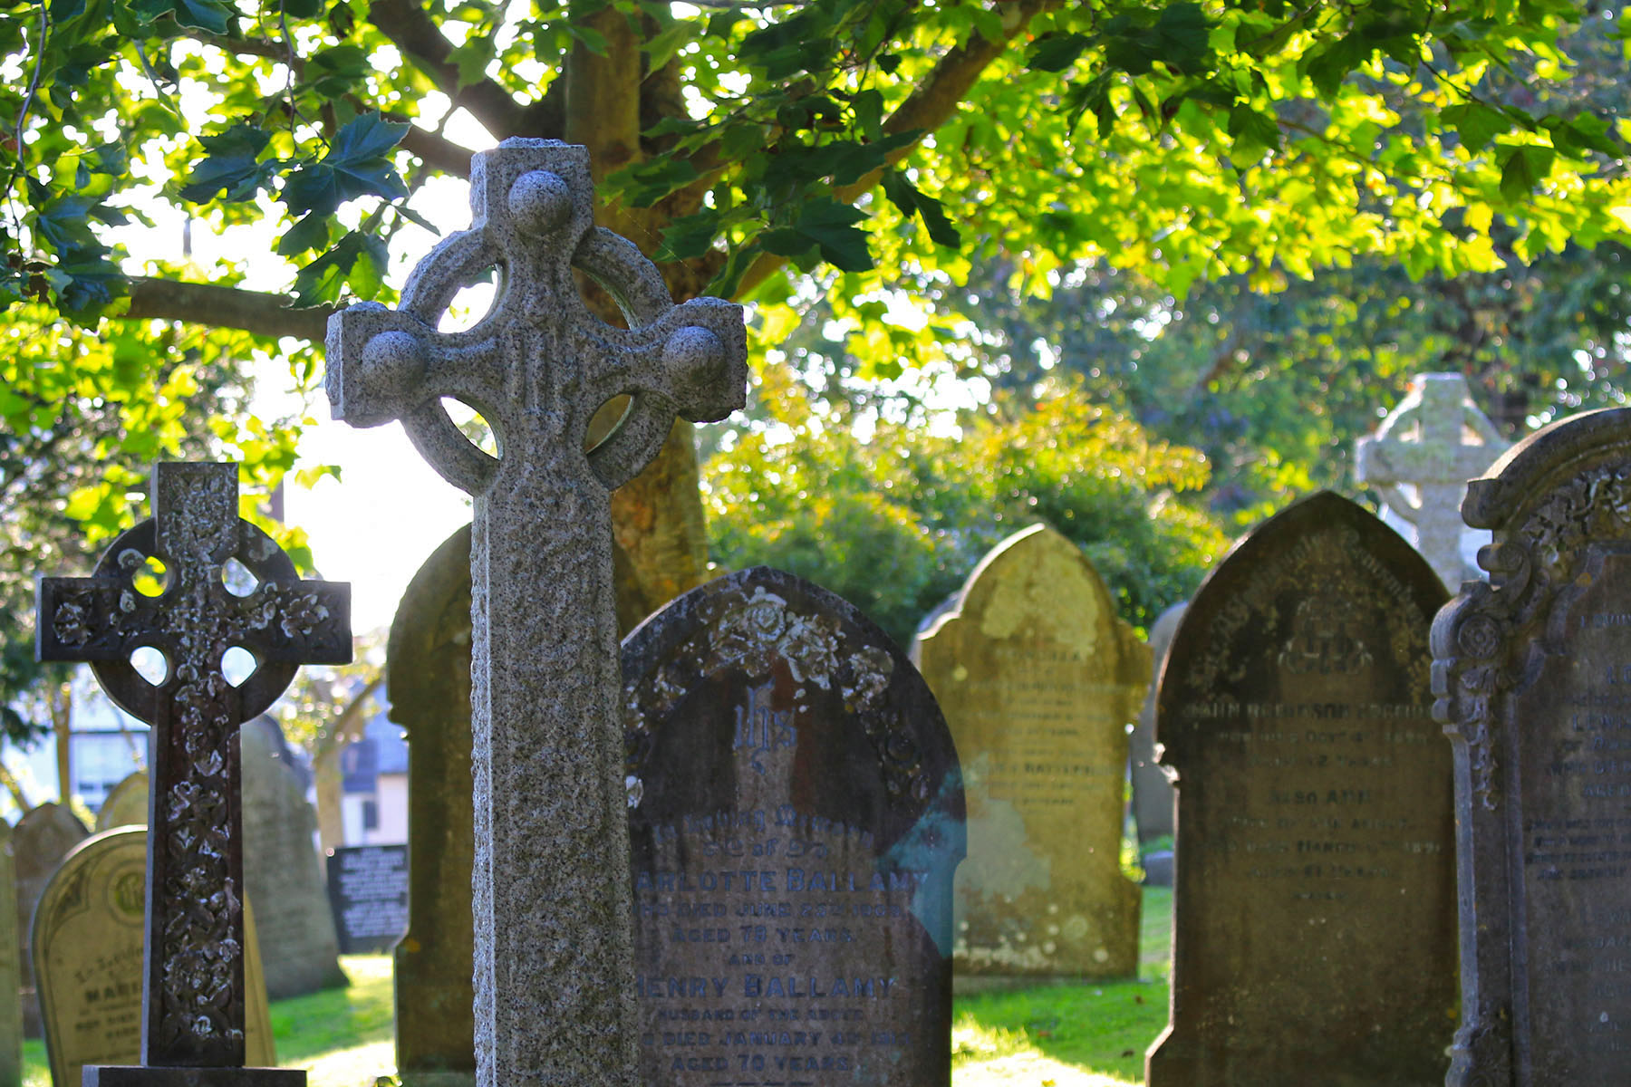

The Churchyard – St Andrew’s Church, Stratton


In Memoriam
Mrs Patricia Dorrington died on 26th October 2017. A Requiem Mass took place at St. Andrew’s on Friday 10th November at 11am. after which her earthly remains were buried in the churchyard.
Pat had been a huge support to our church family here in Stratton having regularly worshipped with us at St Andrew’s since 1997. She had been a FoStA member for several years. Pat was always very involved with all aspects of church life and took on many responsibilities, was a keen member of the choir and very well known within the ringing fraternity. We shall miss her wise and knowledgeable counsel and her kindliness and keen sense of humour. Pat’s steadfast fortitude and faithfulness, even in adversity, was an example to us all. She will be sorely missed.
May she Rest in Peace and Rise in Glory.

Mr William John Heard died on 2nd December 2017, aged 92, after a protracted illness. His earthly remains were cremated and are to be interred in the churchyard at St Andrew’s. John was a Local Boy and although he had lived away for many years his heart remained in Stratton. He took a keen interest in the church and churchyard and had been a Friend since the scheme’s inception in 2008. He will be sadly missed by his family and many friends.
We offer sincere condolences & our prayers to both families.

Developments for the Rear of St. Andrews - Update
In the Autumn Newsletter I reported on our proposals for the reordering of the back of the Church to create an open, multi-purpose area, complete with a new kitchen, in order to improve the facilities that the church can offer and make the space work better for us. A Petition for Faculty was submitted in September 2017 and I am now pleased to report that this has been successful, with the Faculty being granted on 31st October 2017. The Faculty states that the work should be completed within 2 years.
Having identified a need in the Church, produced proposals to respond to this need and now been successful in obtaining permission for these proposals, we are obviously keen to progress with the work as quickly as possible. However, funds are not currently available to allow the entire project to proceed immediately. The intention is therefore to deliver the project in three phases, as funds become available, with each phase involving only one area of the church. This will allow the normal day to day activities of the church to continue with as little inconvenience as possible. On completion of each phase an immediate benefit will result, whilst giving us time to fundraise for the next phase. The phases are as follows:
Phase 1: Relocation of the font. This will immediately open up space in the south-west corner of the Church.
Phase 2: Removal of pews from the rear of church. Following this phase the open space at the back of the church will be complete, allowing more flexible use of the church.
Phase 3: Relocate Vestry and install new kitchen. This will complete the project.
The total cost of the project is anticipated to be in the order of £40,000 to £45,000. At the current time we have been given a grant of £5000 from the Blanchminster Trust and the FoStA committee has agreed to match-fund this, which will allow Phase 1 to go ahead in spring. Applications for grants to other funders are currently being submitted and it is hoped that this will allow Phase 2 to start in the summer.
Fundraising events have also allowed the setting up of a kitchen fund, which currently stands at just over £4000. This fund is specifically for the kitchen and therefore cannot be used until Phase 3. We would like to think that this phase can be completed before Christmas, but this will clearly be dependent on future fund raising and successful grant applications.
These are exciting developments at St Andrews, not only providing improved facilities for our own use, but also to allow more community use of the church building and encourage greater community involvement in church based groups and activities. The FoStA committee and the PCC of St Andrew’s Church are extremely grateful for the unfailing generosity of the FoStA membership which has made possible the grant already provided for Phase 1, and we hope that this generosity will continue to help facilitate the successful completion of this project.
Simon Waring. Churchwarden

From a Windsor Friend
I cannot remember the exact date when my father decided that the time had come to buy a holiday home in the West Country. As the economy began to improve after the dreary post-war years we had spent a few very happy holidays in Bude staying respectively at the Falcon and the Grenville. We loved boating on the canal and surfing on the glorious beaches and so my father began to look for a property in Bude. However the instant we saw Tree Hill House in Stratton we were smitten and the purchase was made. In the first years I can remember the buildings on what is now Rattenbury Gardens – Mrs Rattenbury’s shop and the cows in the barn at the bottom of the street. Steak & chips and chicken in a basket were enjoyed at the historic and atmospheric Tree Inn. Until I married in 1971 I came with my parents, brother and assorted family friends at least twice a year – usually Easter and early September. After ’71 our time was limited but we came at least once annually. Every Easter I would attend the service at St Andrew’s and although found the service rather ‘high’ compared to the more ‘low’ services of my church in Windsor, I thought the building beautiful with a great sense of worship continuity throughout the centuries.
The church I attend in Windsor is in the busy High Street and does not have the advantage of being in a residential district. Several of our fairly small regular congregation live a bus or car ride away (parking is a nightmare!). However we focus on being there for visitors and the Windsor Community. Many organisations hold special services in the church throughout the year. Staging was put in a few years ago and several concerts & lectures including those organised by the Windsor Festival are held. Over the years many crisis meetings agonised over how to keep the church in good repair. Several successful fundraising campaigns helped with specific urgent structural items but many things were just put on hold. For some time I had had the thought that a Friends Scheme would be beneficial but really did not get the support to progress this until one day I had an invitation to join the Friends of St Andrew’s Stratton. This was very encouraging – if a small village church could have a successful scheme then surely a large community church in very famous, historic town could. This coincided with the arrival of a new Associate Priest who became very enthusiastic and supportive. It took a while but the Friends of Windsor Parish Church was formed and is now in its sixth year. We are really indebted to Val & Ian Barker for their interest, support and very helpful advice which certainly gave our small committee the momentum to achieve our goal.
Our aim is to keep the church looking well cared for and welcoming. Over the years we have organised several projects from carpet cleaning to restoration of stained glass windows, from bulb planting to cleaning of memorials. We have not held any large fundraising events but so far sufficient funds have come from members’ subscriptions, supporters’ donations, gift aid, coffee mornings, annual afternoon teas, and an after Sunday service lunch.
We would be delighted to welcome any FoStA members to Windsor. If you are in the area do get in touch and have a guided tour of our Parish Church.
Christine Heybourn
Windsor February 2018
NB the Parish Church of St John the Baptist, New Windsor is in the town centre close to the Castle and Guildhall. It is open daily from 10 am to 4pm. Among many points of interest are: the magnificent painting of the Last Supper by France de Kleyn (Court Painter to James 1st; carvings by Grinling Gibbons; altar mosaics by Antonio Verrio.
________________________________________________
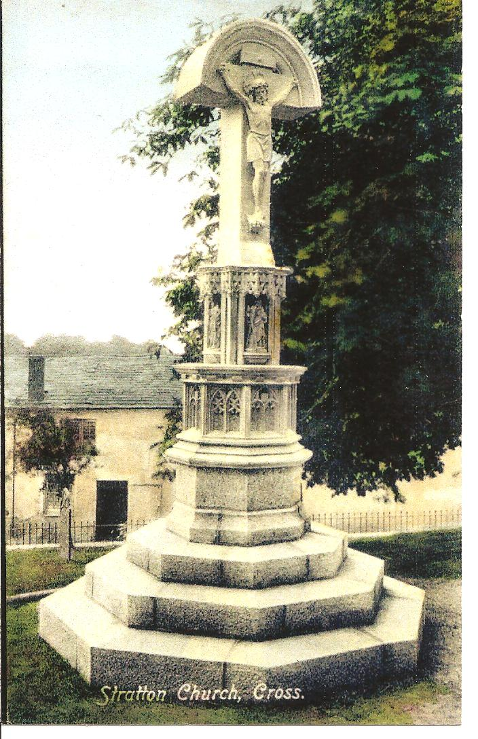
The Calvary Cross (Update)
Happily, this time, I do have something to report!
I have fortunately been able to enlist the help of two experts with my on-going research; Mr David Thomas, Archivist at Cornwall Records Office and Mr Andrew Langdon of Truro, the leading Cornish Cross expert. Both gentlemen have been able to give me some information and although the case is far from closed at least there seems to be a reason for the removal of the cross.
In a minute in the Stratton Parish Church PCC minutes dated 1 December 1941 it states: ‘Wingate Memorial. The question arose as to whether the memorial was safe in view of the crumbling at the base of the figure and although the Vicar felt it could last as it was until after the war, when certain additions could be made, Mr Kivell (the then Churchwarden) suggested that the Sec asked Mr Roberts, monumental mason of Bude, to view the memorial and report as to its safety and if anything should be done to it.’
This is some 40 odd years since the memorial was erected.
In Mr Langdon’s correspondence he says: ‘After reading the article you forwarded to me, (that written by Ed in the Spring 2017 edition of the FoStA News Letter) I would suggest that the cross may have started to crumble away and become unstable.’
These comments seem to be borne out by the minute from the PCC records as above. Interestingly he goes on to say:
‘I have quite a list of Mr F.H.Nicholl’s work. He lived in Lewannick and owned the Polyphant Stone Quarry. He was commissioned to carve several elaborate crosses during the late Victorian and Edwardian period, to designs by his namesake Arthur G Langdon. Langdon’s designs included interlace, scrollwork and knot-work patterns and were wonderful pieces of sculpture, however they have all started to crumble away. One lies in the churchyard at St Stephen by Launceston, another in the churchyard is badly damaged. Others survive, although damaged, at St Thomas by Launceston, Lewtrenchard and Lewannick – the one in the latter churchyard is in memory of Mr Nicholl’s wife. In all cases the upper surface of the Polyphant Stone containing the fine sculpture is lifting and splitting due to the damp Cornish atmosphere. I have also discovered that I have a postcard of the monument so I can now add this to the list of Mr Nicholl’s work’.
I still feel that it is worth further research into the time between early in the year of 1941 and 1947 when it was replaced by the wooden cross. More news next time – maybe! Ed

The Baptismal Font
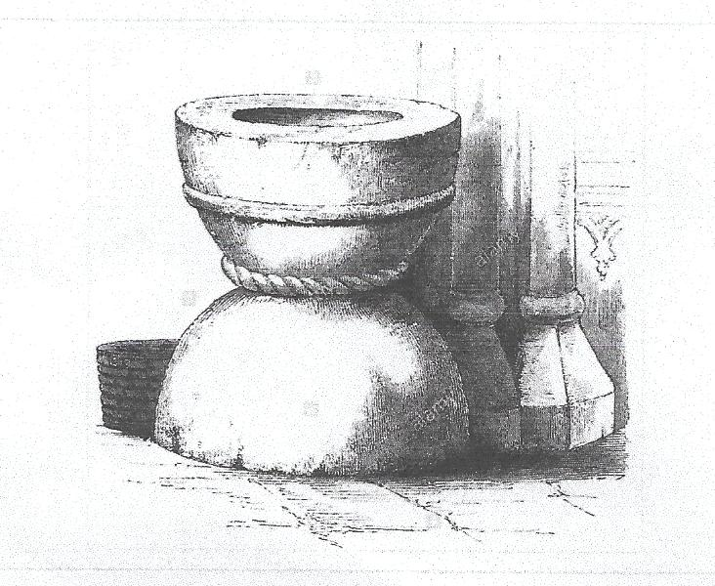
Just in case there is any discomfort about moving the Font to a new position I thought it would be interesting to show this photo of how it looked in 1844 when a wood engraving of it was published in Paley’s book on Fonts. It was described as ‘being of stone and dating from the Norman period, 1066 to 1150 or so’. (It was in position, at that time, by the south pillar.)
As can be seen in the illustration, the bowl with its single round moulding and lower cable moulding was retained when the Victorians moved the font to its present position and mounted it on to an octagonal granite pedestal and then disposed of the inverted bowl on which it sat.
When it is moved it will be to the right of the main entrance as you come into church and not hidden behind the door, as it is at present, somewhat masking its liturgical significance. Ed
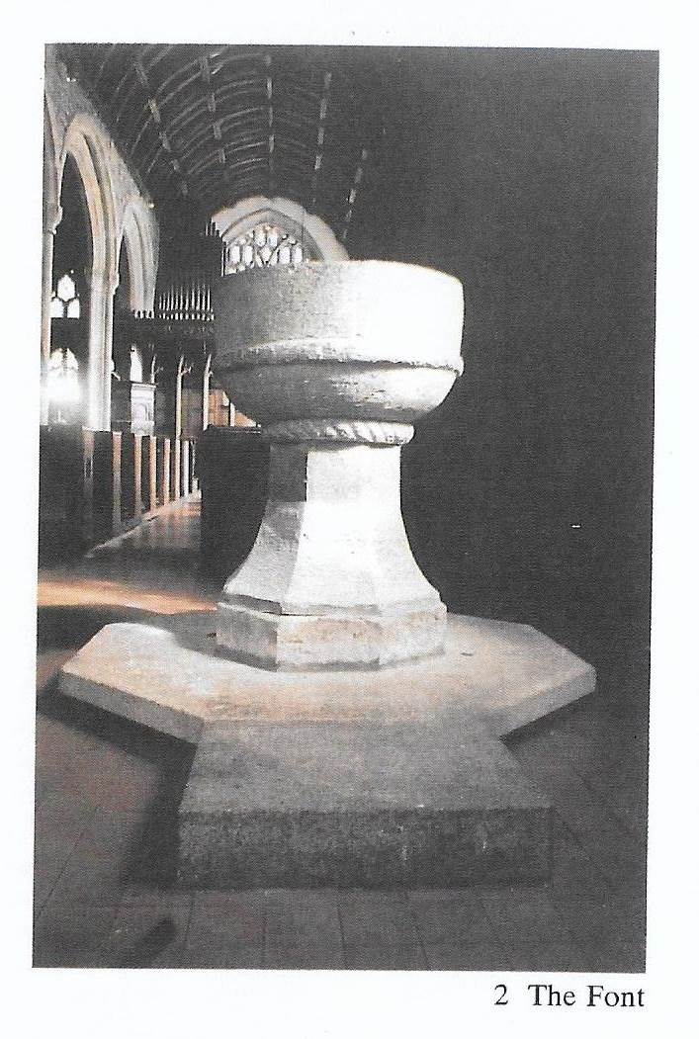
The Font in the South West corner of the church.
Note the Victorian granite pedestal

_______________________________________

Dates for Your Diary

- Friday 25th to Monday 28th May inclusive Flower Festival at St. Andrew’s from 10am to 5pm
- Saturday 16th June Stratton Summer Fete at Long Paddock, Howard Lane from 1.30pm – 5pm
- Saturday 28th and Sunday 29thJuly 10-4pm daily Produce & Horticultural Fair at St. Andrew’s
- Saturday 18th August FoStA Craft Fayre in the Church 10am to 4pm
- Saturday 27th & Sunday 28th October FoStA Craft Fayre in the Church 10am to 4pm
The online monthly calendar is kept up to date by our Web Master with services and events so do check for further details at www.fosta.org.uk

* * Items for Sale * *
Please remember the on line FoStA Shop.

FoStA Newsletter is published by
St Andrew’s Church, Stratton, Cornwall. EX23 9DW
Members are sent a copy by post and
a PDF version is available on the FoStA web site - www.fosta.org.uk

Parish Priest: Father David Barnes
1 Lanvean, Cleavelands, Stratton, Bude. EX23 8LJ
Tel: 01288 352254 e-mail: d.barnes645@btinternet.com

Newsletter Editor: Mrs Val Barker
Chynoweth, Bowden, Stratton, Bude EX23 9BH
Tel: 01288 353435 e-mail: memsec@fosta.org.uk

** If you are prepared to view the newsletter on line or print it yourself, please let me know. **

