Friends of St Andrew’s Church  
Stratton, Cornwall



**Newsletter Autumn 2016**

Volume 8 Issue 2

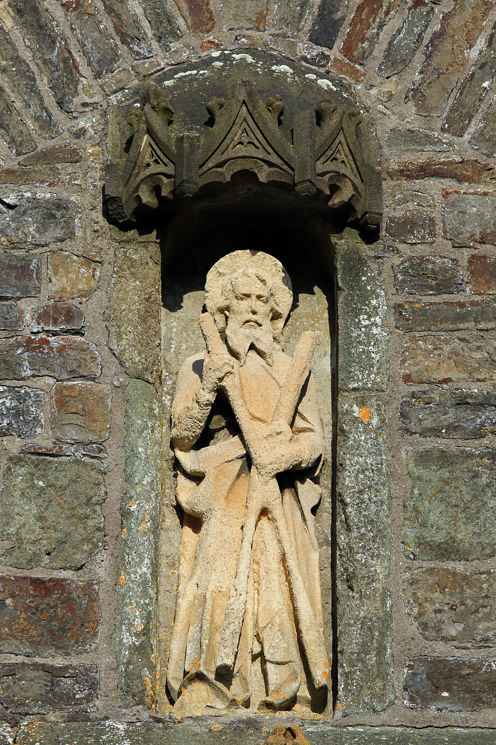

Dear Friends

As September draws on we find that the landscape around us changes and we move from the busyness of summer into the golden colours of autumn, the whole vista around St. Andrew’s Church changes into a vibrant blend of reds and golden browns.

This year our Bishops have asked us to come up with an action plan that will enable our churches to move forward so that we can discover “God’s Kingdom and Grow the Church”. Throughout this time, members from all of our churches have met together to discuss how we can go about achieving this.

During the last week of July, we were visited by Bishop Chris and members from Church House to see what progress we have made. As a Cluster of Churches we presented six projects to the bishop.

1. To discover a more specific vision for our churches.

2. To learn how our worship may be improved.

3. To enable our buildings to reach their full potential.

4. To be more accessible to our local schools.

5. To help our spirituality move forward through meditation.

6. To be better communicators, with our communities,

through the use of social media.

It is hoped that these projects might enable our churches to move forward and be more relevant to today’s society. We are holding a more detailed presentation on these projects on Thursday 22nd Sept at 7.00pm in St. Michael’s Church in Bude. Please feel free to join us.

Yours in Christ’s service,

Fr. David

**Val Barker writes:**

At this time of year I wonder why on earth I took on this job of Secretary and Editor for the FoStA Newsletter and then I read some of your notes, letters and e-mails and I have the answer. It is a joy to hear from you and such an encouragement to us here in Stratton and especially for the FoStA committee who work so hard to support the Friends. Thank you all!

Many of you have given extra donations this year over and above your subscriptions and when buying your raffle tickets and this has helped enormously in keeping the accounts healthy. We have also received gifts from FoStA members; one Friend kindly gave a copy of Canon Bone’s, ‘The Story of Stratton Church’ and another person gave a copy of the Revd Tom Gilbert’s ‘Stratton Church Guide’; a new Diocesan Flag was presented to the church and also a quantity of prized, high quality incense which you can read more about in an article starting on page 7. All this generosity is both acknowledged and very much appreciated.

We have, in our membership, several people directly related to priests who have served out ministries here at Stratton and this fact has done much to feed my appetite for St Andrew’s social history. This interest started, I suppose, when as the Churchwarden in the 1990s I was given the job of sorting out some of our records that needed to be catalogued and then taken to the Truro Records Office for safe keeping.

One of these records was a letter written by the Revd J.G.Packer (Curate at Stratton 1865 – 1868) and dated July 1 1868, Stratton Vicarage, and with it a list of lots of parishioners who had contributed to the cost of purchasing a new item of communion plate, for the church, to replace an old and worn pewter piece which had been in use since the late 17th century. Each person had given quite a small amount of money but added together it was a princely sum.

Two things struck me – firstly, the priest had personally and very carefully made a record of the name of each donor and how much each had contributed and secondly that the new piece was purchased by the probable sacrificial giving of members of the church family rather than having been received as a gift from one wealthy patron. I have researched some of the names on the list and they include local professionals, tradespeople, domestic servants and agricultural labourers – a wide mix.

In 2005 I had the good fortune of meeting Revd Packer’s great-granddaughter when she made a visit to St Andrew’s with her husband. They were able to give me some interesting information about their forebear and since that accidental meeting in the church they have both become life members of FoStA and visited again earlier this year and to my delight brought with them copies of pages from the Revd Packer’s notebook, in which he makes reference to Stratton, and even better – his photograph. There is always something special about being able to put the face to the name.

Every time I see the High Altar at St Andrew’s lovingly prepared for the Lord’s Supper I remind myself of how fortunate we are to have had all those who have gone before, priests and people, who have done so much for the life of our church and thank God for them.

I have already received a great deal that has enriched St Andrew’s archives, but if you have anything you think we might not have, do please share it.

Finally, do remember that we have a FoStA ‘Shop’ and our present stock may be viewed on our website at [www.fosta.org.uk](http://www.fosta.org.uk) under the Fundraising tab.

With every good wish from me and all at St. Andrew’s,

Val

#### Obituary:

**Peter Midelton**

Pete Midelton, a much respected local man, died after a short illness on 22nd May and the funeral service and celebration of his life took place at St Andrew’s church on Friday 3rd June 2016. He will be sorely missed by his family and many friends and we offer our condolences and prayers to his son Jason and the whole family. Donations in his memory, amounting to £337.02p, were kindly given to FoStA at the request of his family.

#### R.I.P.



#### Dates for Your Diary

* Saturday 29th and Sunday 30th October   
  **Craft Fayre** at St. Andrew’s
* Saturday 26th November  
  **Mini Fayre and Gift Day**

Although these events are not specifically for FoStA funds I know there are many of you who will wish to put these dates in your diary.

**Listed Places of Worship Roof Repair Fund - Update**

In the Spring 2016 issue of the Newsletter it was reported that a 2nd application had been made to the LPoW Roof Repair Fund for a grant to carry out the re-slating of the Chancel roof and the re-bedding of the main roof ridge tiles. Sadly, at the end of June we heard that our application had been unsuccessful and that once again we have missed out on this source of funding. There is currently no indication that further government funding will be available from this source.

This of course was very disappointing and means that the money will not be available to allow the roofing work to start this year, nor in the immediate future. There is no doubt however that it will need to be done at some stage. The deterioration of the Chancel roof was first highlighted in the 2006 Quinquennial report, and once again in 2011, and is clearly an issue that cannot be ignored indefinitely.

The Diocesan architect carried out his 2016 Quinquennial inspection at the beginning of August and we are currently awaiting his report, not only to hear his views regarding the current state of the roof, but also to learn if there are any other urgent repairs that will need immediate funding.

In the meantime the PCC and the Fabric Committee have discussed other projects that we would be keen to progress should funding be available. These include improvements to the Churchyard path from the Lych Gate which is currently uneven and not very wheel chair friendly, and the development and opening up of the area at the back of the church, including a new kitchen, to provide safer and improved facilities for activities using the church building.

As reported in the last Newsletter, FoStA had agreed to make a contribution of £5000 to the roof repairs to be included as part of the LPoW application. As the roofing works are now unlikely to be going ahead soon, the FoStA Committee is keen that this contribution be used for an alternative project. However, it is thought best not to commit to any specific project until the 2016 Quinquennial report is received from the Architect, and the PCC has had the opportunity to discuss its implications.

*Simon Waring – Churchwarden*



**FoStA GRAND PRIZE DRAW RESULTS**

1st Prize: Wine Bottle Coaster won by ticket 0077

2nd Prize: Family Entrance to Eden Project won by ticket

0812

3rd Prize: Highgrove Garden Book won by ticket 0833

4th Prize: Sastrugi – South Pole Book won by ticket 0684

5th Prize: Sainsbury’s Voucher won by ticket 0407

Congratulations to our lucky winners and a big Thank You to all who supported this fundraising effort. We made a profit of £627. An excellent result.

**Gifts from the Orient**

The Magi and the gifts they brought to the infant Jesus have a very special place in the Christmas story. Our visit to Oman earlier in the year inspired us to acquire some frankincense for St Andrew’s to be used at important festivals such as Easter and Christmas.

Frankincense (and its botanical cousin myrrh) have long been surrounded by mysticism and credited with almost magical powers. They were once more expensive than the third gift of the Magi – gold. There are references to frankincense as far back as 2000 years BC in Egyptian hieroglyphics. In the books of the Old Testament it is mentioned in Exodus, Leviticus, Malachi and the Song of Solomon - and also of course in the best known reference to the Wise Men in Matthew 2 verse 11.

Frankincense is extracted from the *Boswellia* tree in much the same way as natural rubber, indeed the Arab word for it is *al-lubān* or *“*that which is milked”. The liquid solidifies into slightly sticky resinous teardrops which can be chewed, dissolved or smouldered on charcoal. Omani frankincense comes from the area around the city of Salalah, in Dhofar, down near the border with Yemen. Every *souk* (market) in Oman has stalls selling the various grades of resin.

Our hotel retained an Omani soothsayer and Keeper of the Incense. Every morning he would light charcoal burners throughout the hotel’s public areas and then invite guests to his sofas for coffee, dates and a few pearls of wisdom while the incense wafted around. He told us where to buy the best frankincense in Muscat. We were sent to find Ali Hamza in Mutrah Souk. He had bags of green/yellow Hojari frankincense from Salalah which we had been told was the best. *Mutrah Souk, Muscat*

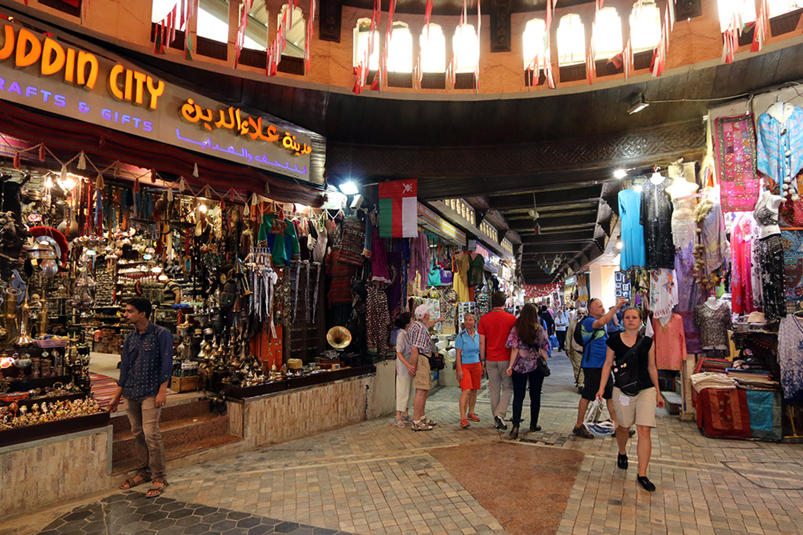

Vast quantities of incense are burnt in mosques, homes and hotels and not just because it makes a nice smell. The smoke (which contains small amounts of a psychoactive drug) appears to have a calming effect on the human senses - reducing anxiety and depression. It has the opposite effect on bugs and beetles, which cannot abide the stuff. The smoke is particularly effective against mosquitos and has also been credited with keeping church roof beams free from wood-boring insects.

*Ali who sold us the frankincense – you can see the bags on the right of the picture.*

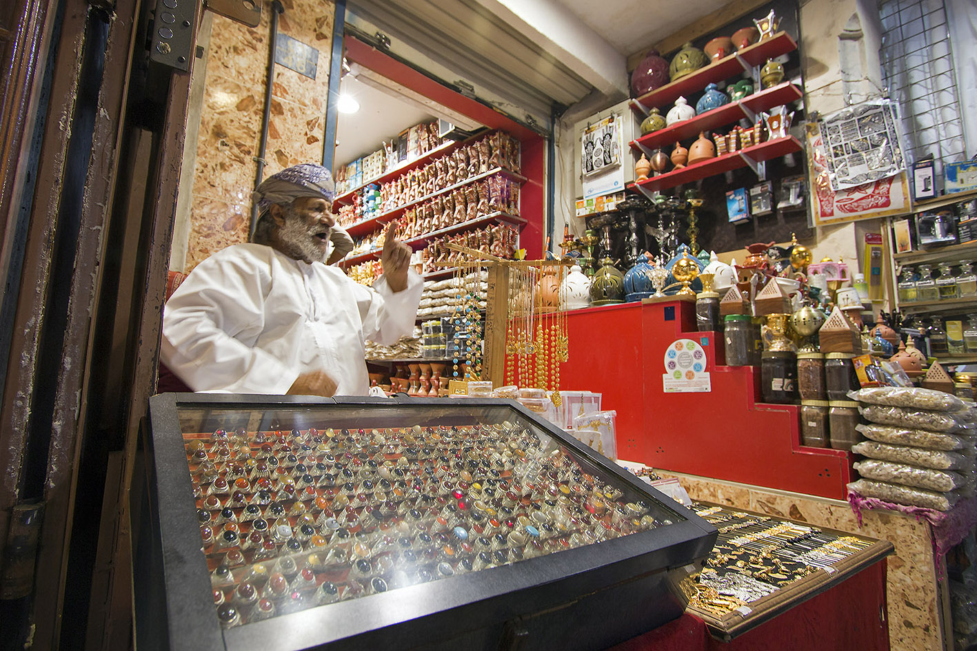

In India frankincense preparations continue to be an essential element in *Ayurvedic* medicine where it is used to treat asthma and arthritis. In Oman it is common to see frankincense being dissolved in water and then sipped to aid digestion. Trials at Leicester University (2013) identified the presence of a compound (AKBA) in frankincense which has been shown to be effective against various forms of cancer. It is also distilled into an essential oil which has a range of uses in perfumes, aromatherapy and skin care products. A few drops in warm water are every bit as effective as balsam or Vicks and far more pleasant to inhale.

*David Goodwin*

THE STATUE of St ANDREW on the TOWER

Many of you have remarked on the reproduction of the photograph of the statue of St Andrew, taken by David Goodwin, which I first used as the front cover for the Spring issue of the Newsletter. It is positioned over the West Door of the Tower high up on the wall in a niche and it isn’t easy to see in detail. The photograph has made this possible.

One of our members wrote:

*‘I am fascinated by the photo of St Andrew’s statue. I think he has the most wonderful expression but I see that erosion has damaged the hands indicating it may be sandstone? I also notice (being an artist) that the head length only goes into the body six times instead of seven, thus making it look as if the bottom of the statue has been cut off and he has lost his feet. It also looks low in the niche. I would love someone to research this sculpture; who carved it and the date it was made and at which workshop. It has the wiff of William Morris workshops. The head is magnificent – love, compassion and sternness radiate from it. I cannot stop looking at it…Perhaps someone would like to write it up for the magazine sometime…’*

I have been in touch with Dr Helen Wilson who is a fund of knowledge regarding the Pinwill family and who came here to Stratton last year and delivered a very informed and well researched presentation regarding some of the church fabric. Here is an article which she has kindly written for this newsletter. Ed

**Statue of St Andrew by Violet Pinwill**

The work of Violet Pinwill is well known at Stratton church, since she provided much of the woodcarving evident today, designed by the architect Edmund H. Sedding. These include the rood screen, the panelling that lines the chancel and St Andrew’s chapel, and the war memorial on the tower screen. So it was rather surprising to learn from a newspaper report that the first piece of her work to adorn the church was in fact a stone statue of St Andrew above

the western doorway. This is a very early example of stone work by the Pinwill company and the report is the only evidence for it.

Western Times, 27 December 1901, p. 6:

STRATTON

*The parish church has been enriched by a statue of free stone being placed in the niche in the tower over the western doorway. It is the work of Rashleigh, Pinwill and Co., Plymouth, and the funds were obtained by Miss Rowe, with whom Miss Hennings co-operated by a sale of photographs of Stratton and neighbourhood. The canopy is of Polyphant stone richly carved. The niche indicates that probably a statue formerly occupied it. Very likely it was denuded in Cromwell’s time. The original canopy is remembered by parents of people now living.*

Violet Pinwill went on to carve several other statues of St Andrew in wood, notably for a reredos at St Andrew in Redruth (1938) and a litany desk at St Andrew with St Luke in Plymouth (1950). None of them are the same as the Stratton statue with the cross so prominent a feature.

*Helen Wilson*

**Cathedrals of Contrast**

In 2015 the 70th anniversary of the end of WWII was commemorated. The War in Europe ended in May 1945 but the battle between the Allies and Japan continued until the Japanese surrender on 15 August 1945. By coincidence I found myself in the Far East in November 2015 and visited two cathedrals which had witnessed the horrors of that War: Holy Trinity Cathedral in Rangoon (now Yangon), Burma (Myanmar) and St Andrew’s Cathedral, Singapore. Although they share a common experience of Japanese invasion and occupation their 21st century identities could not contrast more. St Andrew’s stands proud in the centre of the old quarter of Singapore and is as lively and vibrant as the modern city by which it is surrounded. Holy Trinity is the very opposite. As Burma starts to emerge from isolation and economic decline during 50 years of military rule, this is mirrored in Holy Trinity’s struggle to survive with a diminishing congregation in a staunchly Buddhist country.

Attacks by the Japanese on Burmese territory occurred two days after Pearl Harbour and long before the capture of Singapore, but the suffering of both countries is indistinguishable and well documented. However, the prolonged fighting in Burma, together with the building of the infamous Burma-Siam railway, has perhaps given greater prominence to the history of that conflict. Thus, Rangoon is not only home to the Taukkyan War Cemetery, beautifully maintained by the Commonwealth War Graves Commission, but also, in Holy Trinity Cathedral, the Armed Forces Chapel, sometimes referred to as the ‘Burma Star’ chapel.

Burma became part of ‘British India’ in 1885 and was formally annexed in 1886. During the 19th century the small Anglican community had worshipped in an old barracks and then the Customs House. There had been plans to build a church, St Andrew’s, and although this did not materialise eventually Holy Trinity church was built, a building without a pulpit, font or organ. Like St Andrew’s in Singapore, at this time Holy Trinity came under the authority of the Bishop of Calcutta. As British influence in Burma grew through the 19th century, so too did the Anglican population and eventually there was talk of ‘upgrading’ Holy Trinity church to a cathedral. Construction began in 1886, with the laying of the foundation stone by the Viceroy of India, and was completed in 1894. The cathedral was designed by the Madras-based architect Robert Chisholm, who also designed the Cadogan Hall near Sloane Square, London. An airy red-brick building typical of 19th century architecture it is more the size of a large parish church than a cathedral. The walls of the Armed Forces Chapel are covered with the shields of all the regiments that fought in the Burma Campaign. However, the human cost of the campaign hits home on a visit to the Taukkyan War Cemetery on the outskirts of Rangoon where 27,000 named servicemen are buried and a further unnamed 6,000 commemorated. The vast majority were in their late teens and early twenties which gives an added poignancy to the words of the Kohima epitaph: “When you go home tell them of us and say, for your tomorrow we gave our today”.

A curious but unexplained feature of the Cathedral is a stained glass window commemorating Grace Darling, the daughter of a lighthouse keeper who became famous in 1838 when she rowed out to the wreck of a ship and saved the survivors. Eventually her fame spread worldwide and her name became synonymous with outstanding bravery. Reason enough for a commemorative window, but why and when it was installed in the Cathedral is not clear. Sadly there was no guidebook to provide the answers. Perhaps reflecting the decline of Anglican worship in Burma, Holy Trinity does not even get a mention in the otherwise comprehensive Lonely Planet Guide to Burma (Myanmar), even though it is next door to the major tourist destination of Scott Market, now known as Bogyoke Aung San Market, which contains over 2,000 shops!

Whereas Holy Trinity Cathedral is a place of faded glory surviving in diminished circumstances, St Andrew’s Cathedral Singapore could not be a greater contrast. It is alive, flourishing and expanding. In effect, it mirrors the thriving State of Singapore. There had been a St Andrew’s church in Singapore since the early 19th century on a site chosen by Sir Stamford Raffles – the founder of modern Singapore. The church was consecrated in 1838 but in subsequent years was twice struck by lightning and eventually declared unsafe. It closed in 1852 but in 1856 the foundation stone of the current building was laid and in 1862 it was consecrated by the Bishop of Calcutta. Funded by Scottish merchants and built by Indian convicts it is a fine example of English gothic architecture. In 1870 it became the Cathedral of the Diocese of Lubuan and Sarawak but it was not until 1909 that the new Diocese of Singapore was created. Like Holy Trinity in Rangoon it has a *porte-cochére* (a carriage porch) to provide shelter from both the scorching sun and the monsoon rains, but there the similarity ends. The inside of St Andrew’s cathedral shows it to be a well maintained place of worship that honours its colonial past but which in the 21st century has expanded with the addition of the architecturally contemporary ‘Cathedral New Sanctuary’ completed in 2005.

In the days before Singapore fell to the Japanese in February 1942, the Cathedral was turned into an emergency hospital. As a result services were suspended and not resumed until after the Japanese surrender in 1945. A reminder of those painful times is the silver-plated ‘Coventry Cross’ which is to be found on the column supporting the pulpit. It is made from two iron nails retrieved from the ruins of the original Coventry Cathedral destroyed by German bombing in WWII. The lectern is almost identical to our own at St Andrew’s in Stratton. It seems the brass ‘flying eagle’ was ‘standard issue’ at one time in church architectural history. As a result it is found in many Anglican churches and cathedrals both at home and abroad. However, in contrast to the contracting congregations in most of the Anglican churches in this country, the cathedral in Singapore is testament to an expanding community. The North and South transepts were extended to accommodate meetings rooms, halls and offices but more space was needed. Eventually, in 2003, a building extension was commissioned to accommodate the growing congregation and support its outreach mission. The $12.5 million project was completed in 2005 and the ‘Cathedral New Sanctuary’ now houses an 880 seat worship hall in the basement while above ground there is a Welcome Centre and an attractive courtyard/amphitheatre all linked by a covered walkway to the main Cathedral and nearby underground station. A greater contrast to Holy Trinity Cathedral, as well as those closer to home, is hard to imagine.

*Meryll Dean*

**FoStA Newsletter is published by  
St Andrew’s Church, Stratton, Cornwall. EX23 9DW**

Members are sent a copy by post and  
a PDF version is available on the FoStA web site - www.fosta.org.uk

**Parish Priest:** Father David Barnes

1 Lanvean, Cleavelands, Stratton, Bude. EX23 8LJ  
Tel: 01288 352254 e-mail: [d.barnes645@btinternet.com](mailto:d.barnes645@btinternet.com)

**Curate:** Revd Alison Hardy

Newfield, Brook Drive, Bude. EX23 8NY

Tel: 01288 488308 e-mail: [reverendalisonhardy@gmail.com](mailto:reverendalisonhardy@gmail.com)

**Newsletter Editor:** Mrs Val Barker

Chynoweth, Bowden, Stratton, Bude EX23 9BH  
Tel: 01288 353435 e-mail: [memsec@fosta.org.uk](mailto:memsec@fosta.org.uk)

*\*\* If you are prepared to view the newsletter on line or print it yourself, please let me know. \*\**

**ACKNOWLEDGEMENTS**

**All Photographs** - taken and printed by kind permission of David Goodwin JP.

My grateful thanks to all those who have submitted such interesting articles for this newsletter.

Ed