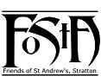
Friends of St Andrew’s Church
Stratton, Cornwall
Newsletter Spring 2024
Volume 16 Issue 1
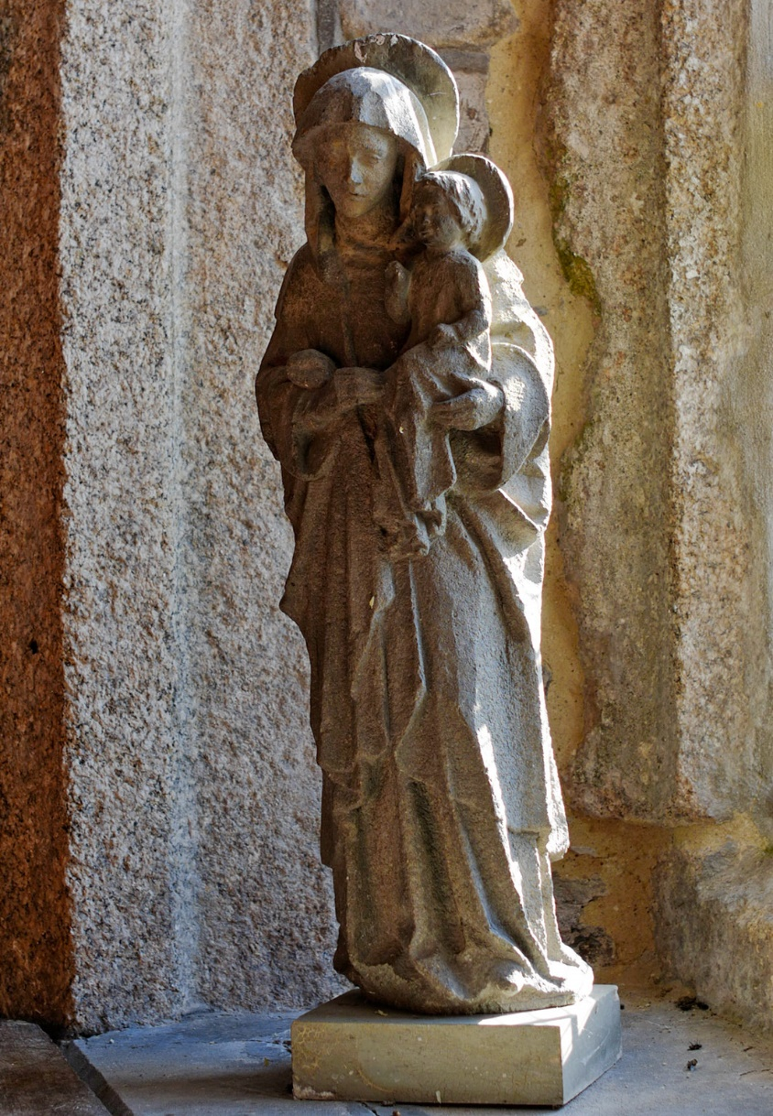

The Virgin and Child
Photograph courtesy of David Goodwin JP

Dear Friends of St Andrew’s,
Val Barker writes –
Dear Friends,
You might be wondering why I am starting this edition of the Newsletter instead of Rev’d Teresa but unfortunately, she has been unwell. She is now back with us again (although she has never truly been away) and working on a phased return basis. She sends to you all her good wishes, thanks and blessing.
As I write this the sun is shining on us here in Stratton after what seems days and days of grey, wet and windy weather which seemed to go on and on. People were getting quite depressed with it all. But the Spring seems to be trying now and the daffodils are in bloom in the churchyard and the trees are showing signs of new life and starting to blossom. How blessed we are.
The Calvary Cross in the Churchyard has been repaired and restored at a cost just over a thousand pounds which was given as a grant to the PCC from the Friends of St Andrew’s Church. More about that later.
St Michael and All Angels, Bude was full to capacity on the morning of 23rd February for the thanksgiving service of the Reverend David Barnes. You may remember that Fr David was the Priest here at St Andrew’s before moving to the Bude Coast and Country Benefice when the parishes were reorganised. He had retired in June of last year and we heard the sad news of his death on 19th January 2024. It came as a huge shock and we continue to remember him and all his family in our prayers.
Although the winter has been fairly quiet it has been busy and there is quite a bit going on one way and another. With the last project having reached a satisfactory conclusion we are now setting our sights on something else. Simon Waring will be telling you about that in his article further on.
My best of wishes to all of you, near and far, and sending grateful thanks, from all at St Andrew’s, for your continued kindness and support of our much-loved church. Val
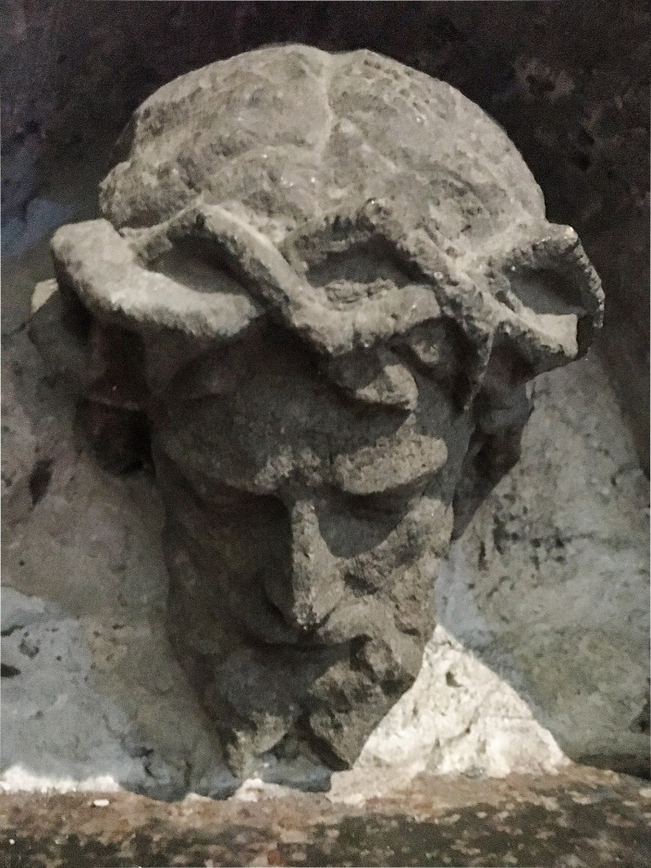
~~~~~~~~~~~~~~~~~~~~~~~~~~~~~~~~~~~~~

The Head of Christ Crucified Thought to be from the original Calvary and now positioned over the Aumbry in the Lady Chapel at St Andrew’s
Calvary Cross (Update)
It has been a year since I gave you the last update about the Cross and since then there has been a flurry of activity with its repair and restoration and some further rather exciting discoveries.
During late summer it was noted that the cross had a definite lean to one side and on examination the base of the stem where it goes into the stone base was found to be rotten and the whole thing was no longer stable. The cross was subsequently propped up with scaffolding and fenced off for safety.
Although the upper part of the monument was not ancient it was agreed by the PCC that it should be restored. All the usual procedures had to be gone through and various specialists at the DAC (Diocesan Advisory Committee) were asked for their opinion and advice. One of these specialists was Andrew Langdon whom you will have heard of before in my previous updates over the last few years. In his subsequent report to the DAC he writes:“First I should say how pleased I am that Stratton PCC is interested in conserving this relatively modern monument, and in presenting the recently-discovered pieces of the original in the church. [See page 9 in the Spring 2023 issue.] The Stratton example clearly shows that Polyphant Stone deteriorates quickly in our Cornish weather, it only lasted 36 years from 1906-1942, however the oak wood Calvary has lasted over 70 years, since 1950!” Later in his report he goes on to say: “I am particularly interested in this monument because it was originally carved from Polyphant Stone; it was designed by E H Sedding and carved by Mr Nicolls of Lewannick, a skilled stone mason who was responsible for a number of early C20 elaborate memorial crosses in east Cornwall. Mr Nicolls was owner of the Polyphant Stone Quarries during the end of the 19th century and the first two decades of the 20th century. He also worked with AG Langdon of Old Cornish Crosses fame. I have traced other examples of his work and they are all in poor condition, some lying down; examples include two at St Stephen by Launceston, St Thomas by Launceston, Lewannick, Lewtrenchard and Little Petherick. Langdon also designed copy of an early Welsh cross, which Nicholls carved in Polypant Stone as a South African War Memorial at Pembroke in South Wales – this memorial has not survived. Mr Nicholls also had the contract for St Paul’s church tower at Truro, and built the Catholic Church at Launceston, including carving a wonderful font for the church, which because it is inside and not subject to weathering is still in very good condition.”
There is a lot more of interest in his report but he finishes by saying: “It doesn’t appear that that any of the original Calvary has survived however it would be interesting to check the churchyard thoroughly”.
That isn’t the end of the story because Andrew visited St Andrew’s to meet the craftsman who was to undertake the restoration and discuss it with him after having reassured himself that the methodology to be used was to the DAC’s satisfaction he accompanied some church members to have a look around the church interior… and he came to some exciting conclusions which to us seem totally logical. Firstly he considered that the statue of the Virgin Mary and Child situated on the window sill in St Andrew’s Chapel may be the original image that was on the reverse (south) face of the original cross and on examination of a better image of the Calvary it is quite obviously a match. His second ‘discovery’ was in the Lady Chapel. Andrew believes that the head of Christ crowned with thorns and carved from Polyphant Stone now situated over the Aumbry is the head of the crucifix on the original Calvary Cross. So, St Andrew’s will have the fragments of the statues in the lower part of the original Calvary and identified figures from the upper section as preserved heritage items of this Wingate Memorial monument.
Mr Mervyn Collins completed the restoration works during January and February of this year and it is standing proud watching over God’s Acre once more.
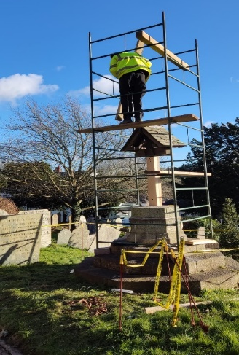
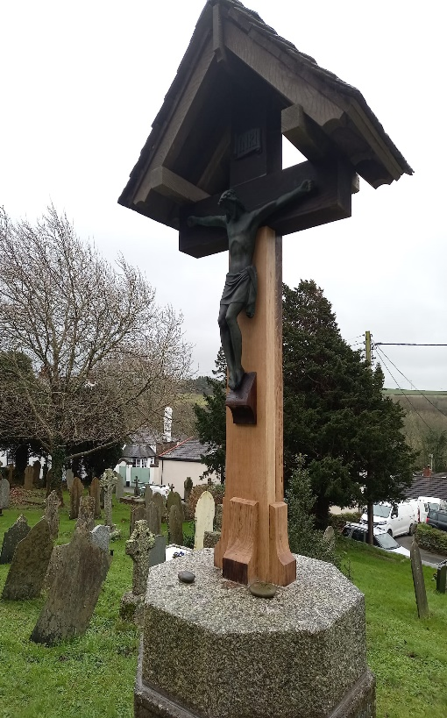

Getting the empty cross into position
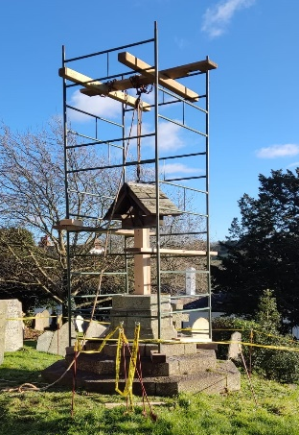

On completion of the work, a letter was received from the DAC Secretary… ‘The Calvary Cross looks wonderful. I have shared the photos with the DAC and they are very pleased. They were also very impressed with your carpenter who we met on the visit so, a job well done I think.’ -Ed
Chancel East Window
In St Andrew’s we are fortunate to have many fine stained-glass windows and visitors regularly leave comments in the visitors’ book complementing the beauty of these windows, especially when the sun is shining through them. Indeed, some visitors to St Andrews come with the specific intention of seeing the stained-glass windows.
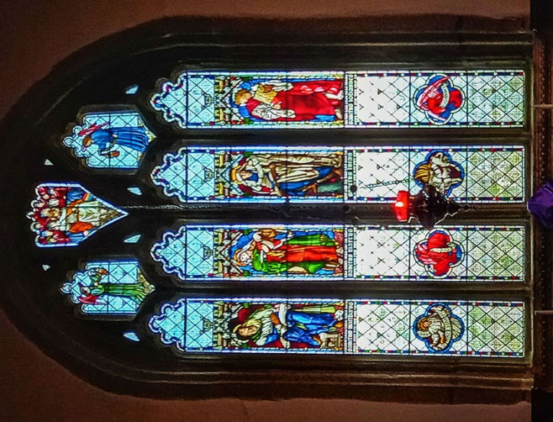
However, one window in particular has special significance, not just to us at St Andrew’s, but also nationally. This is the East Window, located in the Chancel in the east wall behind the High Altar. This is one of only ten windows in the whole diocese, and these in only six churches, that was designed and manufactured by the firm of William Morris. This window is also the sole representative in the county of the decades of the 1870’s and 80’s when it is generally considered that the firm produced much of their most important work. It was inserted in 1874.
William Morris was one of the most significant cultural figures of Victorian Britain and the figurehead for a massive artistic movement in the nineteenth century that was a reaction to the upheavals of the Industrial Revolution, and an attempt to return to traditional craftsmanship and artistic skills. His ideas and designs profoundly influenced interior decoration throughout the Victorian period and have continued to do so to this day.
The window in St Andrew’s includes four main lights with a central figurative band depicting the four Evangelists, below which are four quatrefoils with their emblems. Above the four main lights are three tracery elements with two censing angels flanking a central tracery depicting Christ in Majesty. The tracery angels were to the design of William Morris himself, while the four main figures and Christ in Majesty were designed by the artist Edward Burne-Jones and the quatrefoil emblems of the Evangelists were designed by the architect Philip Webb. Edward Burne-Jones and Philip Webb were core partners in Morris’ firm.
The figures of the four Evangelists are of particular interest. It was Jesus College in Cambridge which in 1872 commissioned the original designs for these figures from Burne-Jones. The figures appear in four separate windows in Jesus College Chapel and were inserted between 1872 and 1874. The windows in Jesus College are large and contain very little clear glass. The Stratton arrangement contains more clear glass, probably to allow the maximum possible light into the Chancel and also possibly to reduce the cost of the coloured glass.
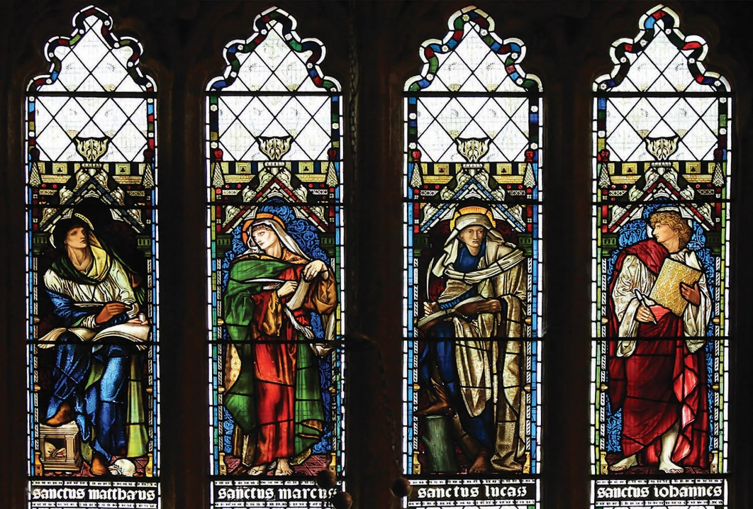
Detail of the Four Evangelists at St Andrews
The original cartoons by Burne-Jones for Matthew and Mark are in the collection of Birmingham City Art Gallery, and that of Luke is in the possession of the Tate Gallery, London. The drawing of John appears to have been lost.
It was very common that designs would be re-used for other commissions, and this was certainly the case for the figures of the four Evangelists. These designs can be found in some configuration, although not necessarily identical, in a total of 32 churches. However, Stratton was the first Parish Church to use the Jesus College designs, and only two years after the original commission.
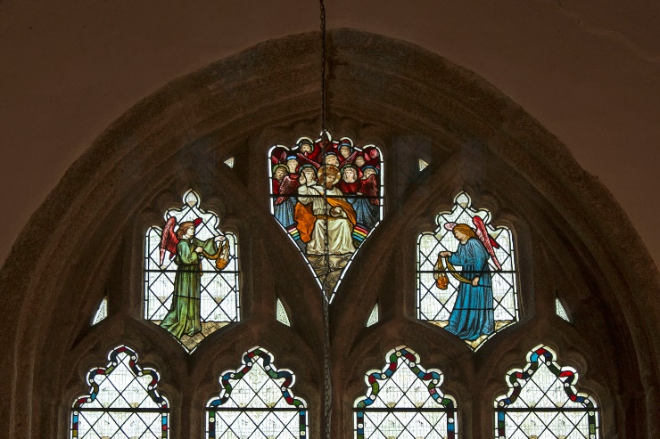
Tracery above the Main Figures
The significance of the East Window in St Andrews was recognised in 2013 when the Church of England launched the 100 Church Treasures Campaign, a fundraising campaign to raise funds for the conservation of artworks in churches throughout the country. The campaign identified 100 artworks most in need of conservation and the list included the East Window in St Andrews, one of only 4 treasures in Cornwall included on the list. Unfortunately, the campaign did not raise enough funds to help all 100 artworks on the list and St Andrews did not receive the hoped-for grant.
The church had carried out some minor repairs to stabilize the window in 2011 following a 2010 condition survey by Holy Well Glass that advised that rusted tie bars were causing damage to the stonework. These tie bars were replaced with non-ferrous bars. The report also advised that the paintwork was deteriorating and was lost from some small areas and also that the panels were showing signs of bowing, but funds were not available to do more significant restoration at that time, and sadly, as we were not successful in receiving a grant in the 100 Church Treasures Campaign, no further work has been carried out to the window.
In October 2023 the PCC asked Holy Well Glass to carry out a further inspection of the window. Their report advised that although the glass is generally in good condition, the paint loss had continued and worsened since 2010, and the main lights have a pronounced bowing that has deteriorated since the 2010 survey. These problems are a cause for concern and the report advised that the church should plan for conservation work to be carried out in the next 5 years. The estimated costs for the works are £47,850 plus VAT.
Following further discussion by the PCC, all were in agreement that due to the importance of this window the responsible course of action was to proceed with the recommended conservation works. A petition was therefore submitted requesting a faculty for these works, and I am pleased to confirm that this was granted in March 2024.
However, it is of course not possible to commence the work until a significant portion of the funding is in place. With this in mind St Andrews will now begin a major fundraising campaign to raise funds for the restoration works, and also investigate funders who we may be able to approach to apply for grants. The FoStA Committee have already confirmed that FoStA will be able to make funds available, for which the PCC is very grateful and as always, the PCC are thankful for the unfailing generosity of the FoStA membership which makes this possible.
Simon Waring, Treasurer

OBITUARIES R.I.P. May they rest in Peace and Rise in Glory
Mrs Jean Dorothy Tippett SRN Jean died on Monday September 11th 2023 aged 92 years and her funeral took place at St Paternus Church, North Petherwin, on Friday October 6th. Former churchwarden of both North Petherwin and Stratton, Jean served her Lord faithfully and loyally all her life. She will be very fondly remembered by all who knew her here at St Andrew’s where she was a very active part of our church family for many years. We offer Frances and all her family condolences, love and continuing prayers.
Mr Michael Garner Mike, a long-time member of FoStA died on Christmas Day 2023. For several years he had attended the Mid-Week Mass at St Andrew’s and it was only when his health began to fail that he was unable to attend. He was always very interested in what was going on at the church and enjoyed the newsletter. We continue to remember him in our prayers.
Mrs Barbara Blood Barbara died on Thursday March 7th 2024 and a wonderful Service of Thanksgiving for her life took place at St Andrew’s Church, Stratton on Wednesday 27th March just short of her 100th birthday. Barbara was a much loved and cherished member of St. Andrews Church, and for several years during that time acted as Church Warden. She was deeply committed to her faith and was always a loving and thoughtful member of the church family. She had a great interest in music, and as well as her involvement in running the Bude Music Society, was in the choir at St. Andrews singing alto for over twenty years. Many of us will have happy memories of fundraising dinners that Barbara held at her house, where we were always made so welcome. Among her skills was flower arranging, but she was active in so many ways to support the community at St. Andrews. Barbara was fascinated by church history and was an excellent guide concerning who to talk to to gain information. One other way in which she inspired us all, was her determination and courage when she was taken seriously ill a number of years ago. Following major surgery, she was back as soon as possible, to play a full part again in the life of St. Andrews. We shall miss her dedication and spirit, but she has left us with some wonderful memories to treasure. We offer Vicky, Nick, Hilary and all her family, condolences, love and continuing prayers.
Anglicans in the South Atlantic:
the Falkland Islands and South Georgia

Sailing to Antarctica was always going to be the trip of a lifetime. Stopping off at the Falkland Islands and South Georgia was a bonus. The former, a group of verdant, albeit treeless, islands which are home to a vast array of birds and seals. The latter, a rocky, snow-covered island uninhabited save for a small research station.
On 19 March 1982 some Argentinian scrap metal workers landed illegally on South Georgia, a British Overseas Territory. At a derelict whaling station they raised the Argentinian flag, thereby setting off a chain of events that would lead to the ten-week conflict on the Falkland Islands between the United Kingdom and Argentina.
The events of 40 years ago are commemorated in various ways across the Falklands including traditional memorials to the fallen and the naming of streets after key British figures in the conflict (Thatcher Drive!). South Georgia remains a desolate island of abandoned whaling stations with little else except for vast numbers of penguins and seals. Apart from the place where the Falkland Islands conflict was triggered, South Georgia’s main claim to fame is as the place where Sir Ernest Shackleton is buried. He is buried in the graveyard of the ‘Whalers Church’ at Grytviken, separated from the church by a derelict whaling station.
The whaling station on Grytviken was founded in 1904 by a Norwegian, Captain Carl Larson, whose son-in-law designed the church. Funds for the building were raised by the station employees with Larson providing the largest donation as well as the stipend for the resident pastor.
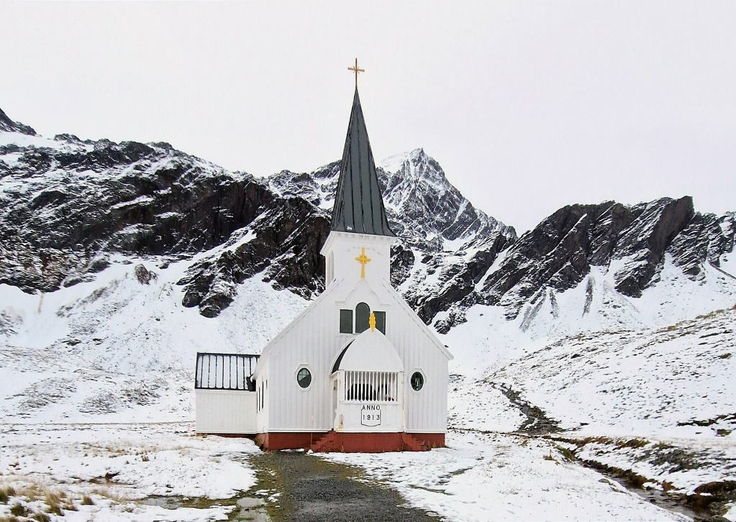
The building was to serve both as a place of worship and as the library for the community. The church is a simple wooden structure with a bell tower and could be considered an early example of a Scandinavian flat pack! It was prefabricated in Norway and then shipped to South Georgia where it arrived in 1913. The station workers assembled the church in their spare time and it was consecrated on Christmas Day 1913 with the two church bells ringing out for the first time at midnight on Christmas Eve.
Getting to the church from the landing zone means passing through areas where elephant and fur seals lie resting like upturned gravestones. Contrary to their apparent docile demeanour, if they feel threatened they can move with a surprising turn of speed. In contrast, the penguins march around quite happily enjoying the company of people trying to reach the church. Although the Whaler’s Church has been visited by very few people, it has been seen by millions around the world because it features in the animated film Happy Feet, the story of a colony of Emperor penguins in Antarctica who visit Grytviken.
Painted white on the outside, the church has a single nave and was built to accommodate 200 people. However, as the first pastor recorded “religious life does not wax strong amongst whalers and left much to be desired”! Even so, it undoubtedly provided a comfortable place for the whalers and their families in an otherwise inhospitable environment, although it seems the library in the north transept was more popular than the church itself! The original library remains to this day together with various plaques and memorials. The Church Register is also on display and records the death, aged 47, of Sir Ernest Shackleton on 5 January 1922.
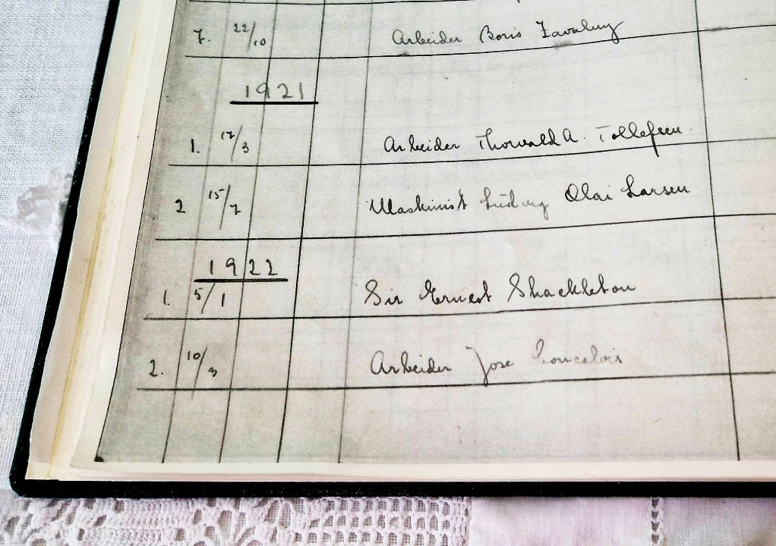
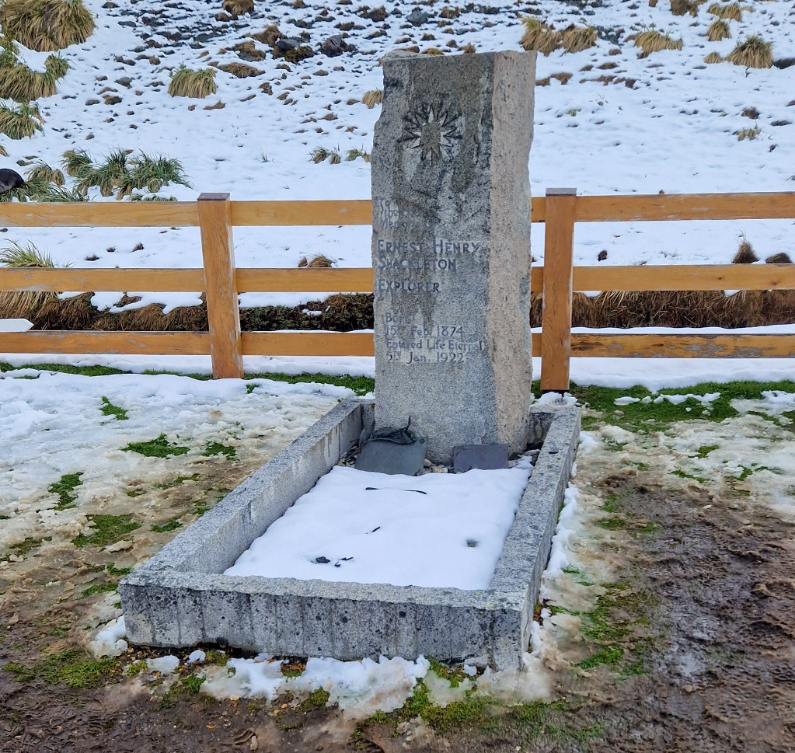
He had made a number of expeditions to Antarctica, most famously in 1914, when his ship Endurance became trapped in pack-ice and sank. He and his crew escaped using lifeboats and eventually made it to South Georgia via Elephant Island. Undeterred by the harrowing experience Shackleton returned to Antarctica in 1921 but died of a heart attack while his ship was moored at Grytviken. At the request of his wife, who famously said that South Georgia had always been her husband’s mistress, he was buried in Grytviken cemetery.
Grytviken church is known as the Whaler’s Church and was designated a Norwegian Evangelical Lutheran Church, although many Christian denominations have used the church with visiting clergy such as Royal Navy Chaplains holding services. Until 2013 it was officially part of the Church of Norway but in that year it was formally handed over to the Church of England. It is now part of the Anglican Communion’s Diocese of the Falkland Islands which is not part of any Anglican Province but is designated as ‘extra-provincial to the Archbishop of Canterbury’. With barely a dozen researchers living at the station, it is a tradition that passing (cruise!) visitors ring the bells upon entry to the church, thereby providing reassurance to the researchers that they are not alone in the South Atlantic.
In contrast to the abandoned feel of the Whaler’s Church on South Georgia, Christ Church Cathedral on the Falkland Islands is an altogether different experience. Situated in Stanley, the capital of the Falkland Islands, it is named after Christ Church Cathedral, Canterbury, England. It is built on the site of the first church built in the Falklands, Holy Trinity, and unlike its wooden predecessor is built from local stone and red bricks.
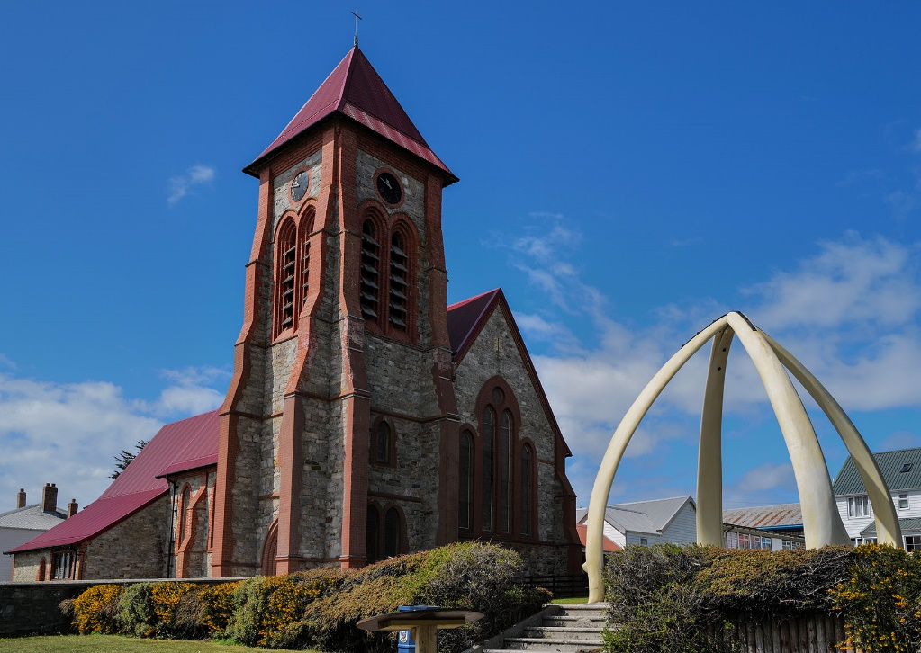
In 1886, Holy Trinity was destroyed by a peat slip, which also destroyed part of Stanley, with services subsequently taken in a sail loft. Christ Church was built between 1890 and 1892 and consecrated in February 1892 by the first Bishop of the Falklands, Waite Stirling, who had previously been a missionary with the Patagonian Missionary Society. He resigned from the Falklands diocese in 1900 to become Assistant Bishop at Wells Cathedral.
Christ Church is the southernmost Anglican Cathedral in the world and is the parish church of the Falkland Islands, South Georgia and the British Antarctic Territories. Unusually, it is a cathedral without a diocese and is an independent autonomous parish outside any Anglican province. Since 1978 the office of Bishop of the Falkland Islands has been held ex officio by the Archbishop of Canterbury who appoints a bishop-commissary who is known as the Bishop for the Falklands. However, the day-to-day running of the church and parish is undertaken by the Rector for the Falkland Islands.
From the outside, it is not is not a grand church, but a rather modest building with a single tower containing five bells. However, the thing that catches the eye is a rather unusual monument in front of the church. In 1922 the giant jaw bones of two blue whales were brought from the South Shetland Islands. In 1933 an arch was created from the jaw bones to celebrate 100 years of British rule and was placed on what became known as Arch Green. The church with its unusual monument appears on Falkland Island banknotes.
The inside of the church is simple with various plaques and banners adding a hint of grandeur. The Order of the Garter banner of Lord Shackleton (Sir Ernest Shackleton’s eldest son) was transferred from St. George’s Chapel Windsor, where it had hung until his death in 1994. Also of interest is the White Ensign flown by HMS Achilles during the Battle of the River Plate in 1939. In all other respects Christ Church is a traditional warm and welcoming church with 19th and 20th century stained glass windows, a two-manual pipe organ and hassocks with designs sewn on them to represent various aspects of the Falklands. Regular services are held as well as special services marking the King’s birthday, Remembrance Sunday, the 1914 Battle of the Falklands and Liberation Day marking the end of the more recent Falklands conflict.
Meryll Goodwin
Post Script, March 2024.
The H5N1 virus, which causes bird ‘flu, has arrived in South Georgia and is killing penguins and seals alike. Consequently, no landings will be allowed for the foreseeable future.
~~~~~~~~~~~~~~~~~~~~~~~~~~~~~~~~~~~~~~~~~~~~~~~~~~~~~~
Date for Your Diary

May 24th, 25th and 26th Flower Festival at St Andrew’s Church
‘These are a few of our Favourite Things’
This event is to raise funds for the church specifically but it is always good to welcome Friends if they are in the area and wish to pop in to say ‘Hello’. Always good to see you.

~~~~~~~~~~~~~~~~~~~~~~~~~~~~~~~~~~~~~~~~~~~~~~~~~~~~~~
Items for Sale
Please remember to visit the online FoStA Shop

Flags from the Tower at St Andrew’s
Recently I received a letter from Paul Davy, who is in charge of the flags at St Andrew’s, in which he suggested that it would be good to have a flag which could be hoisted up the flagpole during a time when no official flag is required to be flown.
He is suggesting that we could hold a competition to design a flag of significance to indicate our commitment to caring for creation. Competition rules would need to be formulated and if this idea comes to fruition Paul has kindly offered to organize and fund the manufacture of the flag to the winning design.
We have had to get official sanction for the idea in principle before going any further (this has been granted) and the Chancellor of the Diocese would have the final say as to the suitability or not of the winning design. A detailed proposal will be presented to the next full PCC meeting which is due to be held in May when the plans can be scrutinized and amended as necessary before permission, or otherwise, is given. It is hoped that at that time a launch date may be decided. Ed
~~~~~
Vexillology… is the study of the history, symbolism and usage of flags or, by extension, any interest in general. As a vexillologist I hope to taunt you to add vexillology to your interests. I thought I would share a bit of history about flags, not only are they attractive but they have had a purpose and flags have served as significant symbols throughout human history, representing various cultures, ideologies and nations. The origins of flags can be traced back to ancient civilisations, where they were used for military purposes, communication and identification.
Ancient Origins The earliest known use of flags date back to ancient Egypt around 3,000 BC. The Egyptians utilized flags as early as 2,000 BC, using them to identify military units with animal symbols. During the Roman Empire, flags called vexilla were employed by legions. These small, square flags featured the emblem or symbol of the legion and served as rallying points during battles. The Middle Ages witnessed the use of flags known as heraldic banners. Knights and feudal lords utilized these flags to represent themselves on the battle field. Maritime flags played a vital role in communication. The Greeks, Romans and Phoenicians used flags to convey messages between ships over long distances. Paul Davy
To be continued …

FoStA Newsletter is published by
St Andrew’s Church, Stratton, Cornwall EX23 9DW
Members are sent a copy by post and
a PDF version is available on the FoStA web site - www.fosta.org.uk

Rector
The Revd Teresa Folland
5 Cormorant Close, Bude. EX23 8FJ
Tel: 01288 352599 e-mail: teresa.folland@gmail.com
Newsletter Editor: Mrs Val Barker
Chynoweth, Bowden, Stratton, Bude EX23 9BH
Tel: 01288 353435 e-mail: memsec@fosta.org.uk

