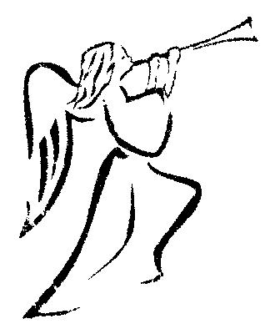

CHRISTMAS CARD
ORDER FORM 2018

All cards are sold with envelopes in packs of 10

Please consider helping with this fundraising event for the Friends of St. Andrew’s (FoStA) this Christmas

(It would be helpful if all orders could reach me by 28th November at the latest. Thank You.)

If mail order required please add £1.50 towards p&p for 10 or 20 cards. For orders of 30 or more cards please add £3.00 for p&p. Cheques should be made payable to FoStA. Thank You.

For those wishing to order by e-mail please use my personal address: ianandvalstratton@hotmail.co.uk
and payment can be direct to the FoStA bank account at: TSB Sort Code:30-91-41 Account No.00586386
Please mark your payment Xcards.

YOUR NAME:………………………….................................................
ADDRESS:……………………………………………………………....................................................................................................................………………………………..POSTCODE:………………………….
TELEPHONE…………………………………………………………...

- Please complete your name, address and telephone number above
- Indicate your selection on the order form
- Please post your orders to: Mrs Val Barker, Chynoweth, Bowden, Stratton, Bude. EX23 9BH
CARD TITLE | NUMBER of PACKS | TOTAL
- St Andrew’s in the Snow £4.75 per pack (New larger card for 2018) |  | £ :
- The Holy Family JMW Turner (A6 size) £3 per pack |  | £ :
- Old Dutch Christmas Triptych (A6 size) £3 per pack |  | £ :
- The Red Lantern (A6 size) £3 per pack |  | £ :
- Christmas Angel (A6 size) £3 per pack |  | £ :
- The Holy Family (A6 size) £3 per pack |  | £ :
- Church Square in the Snow (A6 size) £3 per pack |  | £ :
- Pot Luck Variety Pack of 10 cards with envelopes  A selection from previous years £2.50 per pack |  | £ :
 | POSTAGE | £ :
 | DONATION | £ :
 | GRAND TOTAL | £ :

